CR-05 - Goals and Outcomes
Progress the jurisdiction has made in carrying out its strategic plan and its action plan. 91.520(a)
This could be an overview that includes major initiatives and highlights that were proposed and executed throughout the program year.

The Salt Lake County Consortium HOME activities: The short term rental assistance provided last spring and summer helped those who are about to lose their rental housing, 364 were assisted in homeless prevention. The allocation of HOME funds to the Road Home, Utah Community Action Program, and Housing Connect assist 100 households who were homeless or at risk of becoming homeless. The Housing Rehabiltiation program of Salt Lake GHHI assisted 60 households, all homes were tested for radon gas hazard and 10 were mitigated, there were 30 households with at least member with asthma who was assisted, 15 aging in place projects were completed wherein the bathrooms were made fully accessible, ramps installed, chair lifts were installed. Rental housing 46 units were retrofited as part of a preservation program. The Opportunity HUB was completed (89 units) but not closed out, Liberty downtown project was completed (56) but not closed out, the Utah Nonprofit preservation project of 46 units was completed but not cclosed out,and the Cornell was completed and closed out (142 units).
The Salt Lake County CDBG Activites: Agencies have continued to be impacted by the COVID-19 in terms of the number of individuals they were able to serve and the type of services that could be provided. Agencies have responded with resilience and innovation to deliver services and respond to negative effects from the pandemic. This year, 14 households received down payment assistance, 134 households received emergency home repairs, and 23 households received rapid re-housing assistance, addressing affordable housing and housing stability for vulnerable residents countywide. Through 4 infrastructure projects, 26,981 people were served, improving a neighborhood park, lighting in an unsafe community, and ADA accessible sidewalks and ramps in LMI neighborhoods. Two non-profit agencies improved accessibility and safety concerns for their public facilities, serving 649 homeless and LMI persons. Additionally, 141 individuals with disabilities or from refugee/minority communities received training and support to find and maintain employment, identify income-generating opportunities during the pandemic, and secure PPP loans and other government and community assistance. Another 1148 individuals were served through public service activities that demonstrate impact improving housing stability, including for domestic violence & sexual assault survivors, homeless, and individuals with substance abuse challenges. A total of 3336 households were served in emergency shelter programs funded by ESG funds.
Comparison of the proposed versus actual outcomes for each outcome measure submitted with the consolidated plan and explain, if applicable, why progress was not made toward meeting goals and objectives. 91.520(g)
Categories, priority levels, funding sources and amounts, outcomes/objectives, goal outcome indicators, units of measure, targets, actual outcomes/outputs, and percentage completed for each of the grantee’s program year goals.

Goal | Category | Source / Amount | Indicator | Unit of Measure | Expected – Strategic Plan | Actual – Strategic Plan | Percent Complete | Expected – Program Year | Actual – Program Year | Percent Complete
Access to crisis assistance | Affordable Housing  Homeless  Non-Homeless Special Needs  Non-Housing Community Development | CDBG: $ / ESG: $ | Public service activities for Low/Moderate Income Housing Benefit | Households Assisted | 0 | 0
Access to crisis assistance | Affordable Housing  Homeless  Non-Homeless Special Needs  Non-Housing Community Development | CDBG: $ / ESG: $ | Homelessness Prevention | Persons Assisted | 100 | 809 | 809.00% | 100 | 809 | 809.00%
Administration of HOME, ESG and CDBG | Affordable Housing  Homeless  Non-Homeless Special Needs  Non-Housing Community Development | CDBG: $ / HOME: $ / ESG: $15247 | Public Facility or Infrastructure Activities other than Low/Moderate Income Housing Benefit | Persons Assisted | 1 | 1 | 100.00%
Administration of HOME, ESG and CDBG | Affordable Housing  Homeless  Non-Homeless Special Needs  Non-Housing Community Development | CDBG: $ / HOME: $ / ESG: $15247 | Public Facility or Infrastructure Activities for Low/Moderate Income Housing Benefit | Households Assisted | 1 | 0 | 0.00%
Administration of HOME, ESG and CDBG | Affordable Housing  Homeless  Non-Homeless Special Needs  Non-Housing Community Development | CDBG: $ / HOME: $ / ESG: $15247 | Other | Other | 1 | 1 | 100.00% | 2 | 1 | 50.00%
Economic stability | Affordable Housing  Homeless  Non-Homeless Special Needs | CDBG: $ / ESG: $ | Public service activities for Low/Moderate Income Housing Benefit | Households Assisted | 0 | 141 |  | 100 | 141 | 141.00%
Economic stability | Affordable Housing  Homeless  Non-Homeless Special Needs | CDBG: $ / ESG: $ | Jobs created/retained | Jobs | 0 | 0
Economic stability | Affordable Housing  Homeless  Non-Homeless Special Needs | CDBG: $ / ESG: $ | Businesses assisted | Businesses Assisted | 10 | 0 | 0.00%
Homeownership | Affordable Housing | CDBG: $ / HOME: $ | Direct Financial Assistance to Homebuyers | Households Assisted | 30 | 7 | 23.33% | 4 | 19 | 475.00%
Housing Rehabilitation & Accessibility | Affordable Housing | CDBG: $ / HOME: $ / ESG: $ | Homeowner Housing Rehabilitated | Household Housing Unit | 250 | 74 | 29.60% | 250 | 194 | 77.60%
Infrastructure | Non-Housing Community Development | CDBG: $ / HOME: $ / ESG: $ | Public Facility or Infrastructure Activities other than Low/Moderate Income Housing Benefit | Persons Assisted | 0 | 26981 |  | 0 | 26981
Infrastructure | Non-Housing Community Development | CDBG: $ / HOME: $ / ESG: $ | Public Facility or Infrastructure Activities for Low/Moderate Income Housing Benefit | Households Assisted | 2 | 0 | 0.00% | 2 | 0 | 0.00%
Public facilities | Non-Housing Community Development | CDBG: $ / HOME: $ / ESG: $ | Public Facility or Infrastructure Activities for Low/Moderate Income Housing Benefit | Households Assisted | 2 | 649 | 32,450.00% | 2 | 649 | 32,450.00%
Rental Assistance | Homeless | HOME: $ / ESG: $ | Tenant-based rental assistance / Rapid Rehousing | Households Assisted | 100 | 123 | 123.00% | 100 | 123 | 123.00%
Rental Housing | Affordable Housing | HOME: $ / ESG: $ | Rental units constructed | Household Housing Unit | 307 | 142 | 46.25% | 307 | 142 | 46.25%
Rental Housing | Affordable Housing | HOME: $ / ESG: $ | Rental units rehabilitated | Household Housing Unit | 46 | 46 | 100.00% | 46 | 46 | 100.00%
Stability and safety | Affordable Housing  Homeless  Non-Homeless Special Needs | CDBG: $ / HOME: $ / ESG: $ | Public service activities other than Low/Moderate Income Housing Benefit | Persons Assisted | 0 | 0
Stability and safety | Affordable Housing  Homeless  Non-Homeless Special Needs | CDBG: $ / HOME: $ / ESG: $ | Public service activities for Low/Moderate Income Housing Benefit | Households Assisted | 0 | 3675 |  | 13 | 3675 | 28,269.23%
Table 1 - Accomplishments – Program Year & Strategic Plan to Date

Assess how the jurisdiction’s use of funds, particularly CDBG, addresses the priorities and specific objectives identified in the plan, giving special attention to the highest priority activities identified.
The 2021 Action Plan called for CDBG, HOME, and ESG funds to be made available for a variety of eligible activities, all of which are aligned with the County’s priorities related to Housing and Housing Stability. The Salt Lake County Housing and Community Development Division adopted the framework of the Social Determinants of Health as a metric that effectively gauges both health and housing stability outcomes. By strategically allocating funds to positively impact social and economic conditions in each of the domains of the Social Determinants of Health, there is corresponding research that supports the expectation that housing stability will improve along with health outcomes. Therefore, for the 2020-2021 program year, projects which were funded demonstrated the capacity to carry out activities that improve conditions in one or more of the six domains: Economic Stability; Education; Community and Social Context; Neighborhood and Physical Environment; Health Care Systems; and/or Food.
HOME funds addressed the priority needs of Housing Opportunities, Rental Assistance, Rental Housing, and Homeownership. These effected change in the domains of Neighborhood and Physical Environment. The GHHI and Lead Safe Housing programs contributed to improvements in the Health Care System domain, continuing to work with the medical providers like University of Utah Health Plans, Select Health, Salt Lake County Health Department Asthma program to assist those with severe asthma.
ESG Funds facilitated Rental Assistance, Rapid Rehousing, and Access to Crisis Services, which also can be measured in the domain of Neighborhood and Physical Environment.
CDBG funds were used to address the priority needs of: Housing Opportunities; Stability and Safety; Homeownership; Economic Independence; Infrastructure Improvements; Creating Economic Opportunity; Access to Crisis Services; and Public Facility Improvements. These activities impacted all six domains of the Social Determinants of Health.
It is anticipated that the implementation of this strategy - the integration of the research-backed metrics of health and housing stability into the prioritized goals of the annual action plan - will facilitate data-informed decision-making for future investments of CDBG and other public and private resources.

CR-10 - Racial and Ethnic composition of families assisted
Describe the families assisted (including the racial and ethnic status of families assisted). 91.520(a)

 | CDBG | HOME | ESG
White | 1,504 | 216 | 2,723
Black or African American | 102 | 23 | 584
Asian | 44 | 6 | 62
American Indian or American Native | 28 | 13 | 268
Native Hawaiian or Other Pacific Islander | 12 | 16 | 143

Total | 1,690 | 274 | 3,780

Hispanic | 761 | 79 | 1,166
Not Hispanic | 1,272 | 195 | 2,921

Table 2 – Table of assistance to racial and ethnic populations by source of funds

Narrative
The GHHI Salt Lake program provides targeted outreach to South Salt Lake, Murray, West Valley City, Sandy, and Magna. All information and educational materials are provided in Spanish, English, and other languages as needed.
The CDBG and ESG program data includes the racial and ethnic composition of families assisted in CDBG-Public Services, Home Ownership, Home Rehabilitation, Facility Improvement, Emergency Shelter, and Rapid Re-housing activities. Jurisdictions completing infrastructure projects provided an estimated area benefit, which did not include racial or ethnic composition data. In addition, CDBG-Public Services sub-recipients reported 343 additional families assisted that were not accounted for in the CDBG total because they identified as multiracial or a combination of two races. ESG sub-recipients reported 259 additional families assisted that were not accounted for in the ESG total because they identified as multiple races. The race for another 90 individuals were not accounted for in the ESG total because the client didn't know their race, refused to share, or the data was not collected.

CR-15 - Resources and Investments 91.520(a)
Identify the resources made available
Source of Funds | Source | Resources Made Available | Amount Expended During Program Year
CDBG | public - federal | 3,530,289 | 3,329,467
HOME | public - federal | 4,170,639 | 3,038,624
ESG | public - federal | 234,272 | 217,705
Table 3 - Resources Made Available

Narrative
Salt Lake County HOME Consortium consists of five of the six Entitlement Cities, the 11 Urban County Participating Cities, 5 Metro Townships and the Unincorporated Areas of Salt Lake County. Salt Lake City is not included in the Consortium or Urban County. This distribution of HOME funds is for the entire Salt Lake County geographic boundaries except for Salt Lake City proper who has their own HOME allocation. $3,038,624.39 funds were expended and $2,652,129.01 funds were drawndown
The investment of HOME funds in the south and southwest part of the county continues to be challenging. It is an increasingly affluent area of the county that has seen significant growth.
The Urban County is comprised of five Metro Townships, the unincorporated area of the County and eleven incorporated cities including Alta, Bluffdale, Cottonwood Heights, Draper, Herriman, Holladay, Midvale, Millcreek, Murray, Riverton, and South Salt Lake. The cities range in population from the Town of Alta at of 383 to Millcreek City at 62,532. Continued coordination takes place with the urban county entities with both the hard costs and soft cost allocation of CDBG funds that. The County administers those funds but does so through an allocation process that includes representation of the various entities included in the Urban County.
The resources made available for CDBG include the annual grant allocation, prior year funds that were recaptured, and program income from repayments of CDBG loans which was utilized for contract reimbursements. The resources made available for ESG include the annual grant allocation, and $16,455 of unexpended funds that were from a prior year (PY19) contract, which were rolled forward into a 2-year contract.
The resources reflected in the table above do NOT include the significant amount of CARES Act funds which were allocated to Salt Lake County. Guidance is still pending from HUD on how to account for accomplishments and expenditures of CDBG-CV and ESG-CV funds, so in the interim Salt Lake County will include the information only in the CAPER narratives. $2,790,850 of CDBG-CV funds were allocated to Salt Lake County, of which $2,216,302 is committed as of the end of Program Year 2020. The balance of $574,548 will be awarded to provider agencies in Program Year 2021. $3,132,150 of ESG-CV funds were allocated to Salt Lake County, of which $$1,960,411.00 was under contract as of the end of Program Year 2020. The balance of $1,171,739.00 will be awarded to provider agencies in Program Year 2021.

Identify the geographic distribution and location of investments
Target Area | Planned Percentage of Allocation | Actual Percentage of Allocation | Narrative Description
Salt Lake County | 75 | 100 | All investments were made in Salt Lake County
Table 4 – Identify the geographic distribution and location of investments

Narrative

Leveraging
Explain how federal funds leveraged additional resources (private, state and local funds), including a description of how matching requirements were satisfied, as well as how any publicly owned land or property located within the jurisdiction that were used to address the needs identified in the plan.
Salt Lake County HOME funds for the funding of rental housing projects which have LIHTC, Salt Lake City, and State of Utah funding. The match this year came from $200,000 of Salt Lake County General funds and from $750,000 of donations given to Salt Lake Valley Habitat for Humanity Project.
Non-profit agencies which provided public services activities with CDBG funds in the 2020 program year, leveraged their awards with an additional $8,499,646.57 in federal, state, local, and private resources.

It is anticipated that as the projects are completed which were funded with CDBG in the 2020 program year for housing, facility improvements, and infrastructure improvements, an additional $1,569,967.00 will be leveraged.
The Emergency Solutions Grant requires a 100% match. Each of the agencies receiving ESG dollars leveraged at the required 100%. Specific ESG matching sources include the State of Utah, LDS Humanitarian Services, In-Kind Contributions from LDS Church, TANF rapid re-rehousing funds, and private donations. The County matches the administrative portion of this grant with County general fund dollars. Non-profit agencies which were awarded ESG funds in the 2020 program year leveraged their awards with an additional $26,628,924.91 in federal, state, local, and private resources.
As a result of the Coronavirus and the funding through the CARES Act, the State of Utah, and Salt Lake County began a rental assistance, mortgage, and landlord assistance program for the residents of the County.

Fiscal Year Summary – HOME Match
1. Excess match from prior Federal fiscal year | 689,920
2. Match contributed during current Federal fiscal year | 950,000
3. Total match available for current Federal fiscal year (Line 1 plus Line 2) | 1,639,920
4. Match liability for current Federal fiscal year | 450,000
5. Excess match carried over to next Federal fiscal year (Line 3 minus Line 4) | 1,189,920
Table 5 – Fiscal Year Summary - HOME Match Report

Match Contribution for the Federal Fiscal Year
Project No. or Other ID | Date of Contribution | Cash  (non-Federal sources) | Foregone Taxes, Fees, Charges | Appraised Land/Real Property | Required Infrastructure | Site Preparation, Construction Materials, Donated labor | Bond Financing | Total Match
Field of Dreams | 07/02/2020 | 750,000 | 0 | 0 | 0 | 0 | 0 | 759,999
Housing rehabiltiation | 07/01/2020 | 200,000 | 0 | 0 | 0 | 0 | 0 | 200,000
Table 6 – Match Contribution for the Federal Fiscal Year

HOME MBE/WBE report
Program Income – Enter the program amounts for the reporting period
Balance on hand at begin-ning of reporting period  $ | Amount received during reporting period  $ | Total amount expended during reporting period  $ | Amount expended for TBRA  $ | Balance on hand at end of reporting period  $
172,934 | 117,656 | 117,656 | 66,877 | 172,934
Table 7 – Program Income

Minority Business Enterprises and Women Business Enterprises – Indicate the number and dollar value of contracts for HOME projects completed during the reporting period

 | Total | Minority Business Enterprises |  |  |  | White Non-Hispanic
 |  | Alaskan Native or American Indian | Asian or Pacific Islander | Black Non-Hispanic | Hispanic

Contracts
Dollar Amount | 0 | 0 | 0 | 0 | 0 | 0
Number | 0 | 0 | 0 | 0 | 0 | 0

Sub-Contracts
Number | 0 | 0 | 0 | 0 | 0 | 0
Dollar Amount | 0 | 0 | 0 | 0 | 0 | 0

 | Total | Women Business Enterprises | Male

Contracts
Dollar Amount | 0 | 0 | 0
Number | 0 | 0 | 0

Sub-Contracts
Number | 0 | 0 | 0
Dollar Amount | 0 | 0 | 0
Table 8 - Minority Business and Women Business Enterprises

Minority Owners of Rental Property – Indicate the number of HOME assisted rental property owners and the total amount of HOME funds in these rental properties assisted

 | Total | Minority Property Owners |  |  |  | White Non-Hispanic
 |  | Alaskan Native or American Indian | Asian or Pacific Islander | Black Non-Hispanic | Hispanic
Number | 0 | 0 | 0 | 0 | 0 | 0
Dollar Amount | 0 | 0 | 0 | 0 | 0 | 0
Table 9 – Minority Owners of Rental Property

Relocation and Real Property Acquisition – Indicate the number of persons displaced, the cost of relocation payments, the number of parcels acquired, and the cost of acquisition

Parcels Acquired | 0 | 0
Businesses Displaced | 0 | 0
Nonprofit Organizations Displaced | 0 | 0
Households Temporarily Relocated, not Displaced | 0 | 0

Households Displaced | Total | Minority Property Enterprises |  |  |  | White Non-Hispanic
 |  | Alaskan Native or American Indian | Asian or Pacific Islander | Black Non-Hispanic | Hispanic
Number | 0 | 0 | 0 | 0 | 0 | 0
Cost | 0 | 0 | 0 | 0 | 0 | 0
Table 10 – Relocation and Real Property Acquisition

CR-20 - Affordable Housing 91.520(b)
Evaluation of the jurisdiction's progress in providing affordable housing, including the number and types of families served, the number of extremely low-income, low-income, moderate-income, and middle-income persons served.

 | One-Year Goal | Actual
Number of Homeless households to be provided affordable housing units | 100 | 140
Number of Non-Homeless households to be provided affordable housing units | 100 | 148
Number of Special-Needs households to be provided affordable housing units | 200 | 201
Total | 400 | 489
Table 11 – Number of Households

 | One-Year Goal | Actual
Number of households supported through Rental Assistance | 100 | 185
Number of households supported through The Production of New Units | 353 | 142
Number of households supported through Rehab of Existing Units | 250 | 74
Number of households supported through Acquisition of Existing Units | 20 | 19
Total | 723 | 420
Table 12 – Number of Households Supported

Discuss the difference between goals and outcomes and problems encountered in meeting these goals.
During this last year, Cornel apartments was completed and closed out-142 units, the HUD of Opportunity was completed 89 units but was not closed out in IDIS, Liberty downtown was completed 56 units but not closed out in IDIS. The preservation project of 46 was completed by Utah Nonprofit housing corporation.
Discuss how these outcomes will impact future annual action plans.
The production of new rental units fell short of the goal, completed not closed out. We have three new rental housing developments underway 255 State-190 units, and two under development Liberty Beacon 145 units to be completed in 2023, and the 144 South Project which will be completed in 2023
Include the number of extremely low-income, low-income, and moderate-income persons served by each activity where information on income by family size is required to determine the eligibility of the activity.

Number of Households Served | CDBG Actual | HOME Actual
Extremely Low-income | 65 | 205
Low-income | 48 | 28
Moderate-income | 35 | 41
Total | 148 | 274
Table 13 – Number of Households Served

Narrative Information
Covid-19 pandemic presented a number of challenges, including increasing supply and labor costs and unprecedented spikes in home prices. Projects funded through the Salt Lake County HOME and CDBG programs supported both increasing new affordable housing inventory and sustaining existing affordable housing and supporting an inclusive recovery for those affected by the pandemic.

CR-25 - Homeless and Other Special Needs 91.220(d, e); 91.320(d, e); 91.520(c)
Evaluate the jurisdiction’s progress in meeting its specific objectives for reducing and ending homelessness through:
Reaching out to homeless persons (especially unsheltered persons) and assessing their individual needs
The Coordinated Entry System (CES) Task Group functions as part of the Salt Lake Valley Coalition to End Homelessness (SLVCEH) and represents a variety of individuals and organizations in the coordinated entry system throughout Salt Lake County. The group has finalized the Coordinated Entry standards to assist with housing placements for homeless persons. The standards were updated with COVID-19 protocols to ensure that those that were most vulnerable were prioritiezed for shelter and services. The community assessment process prioritizes households in most need and ensures services are received in a timely manner by using information gathered from the housing needs assessment tool. Our community is currently using the VI-SPDAT, but are looking to transition to a tool that accounts for racial disparities in the system. Additionally, three weekly “Housing Triage” meetings are held with providers to review the community “by name list” and facilitate the prioritization for housing referrals and to help ensure services are received in a timely manner for families, chronic and/or vulnerable singles, and Veterans.
Access Points into the CES are found throughout Salt Lake County, based upon a “no wrong door” model, including resource centers. Access is also possible via a phone line for those who are unable to physically get to an Access Point. The phone line is operated by Utah Community Action, who manages diversion and coordinated intake at each of the homeless resource centers.
Street Outreach teams work to ensure that services are available to those unsheltered individuals and households who are least likely to apply for services. Known as a “mobile” access point into Coordinated Entry, Outreach teams are trained to conduct screenings and housing needs assessments (VI-SPDAT and full SPDAT) for those who are unsheltered. Since many unsheltered and chronically homeless people will initially decline assistance, mobile outreach teams will engage with these individuals over an extended period in an effort to get them connected with services. These teams were expanded in response to COVID-19 as we have seen a rise in those persons experiencing unsheltered homelessness.
Our community uses the The Point in Time Count data to provide baseline data, inform funding decisions and to determine what programs are needed. Because of COVID-19, we conducted an observation only count to help ensure that persons experiencing homelessness and volunteers were safe with a second Point in Time Count scheduled on September 10 to gather more detailed information.
The Crisis Response Core Function Group of the SLVCEH works to connect clients with crisis response services that will support their efforts to find safety and security, maintain stable housing, and make homelessness rare, brief, and non-recurring. Their work has included integrating data into planning efforts, analyzing racial disparities, and increasing access to transportation. Moving forward they plan to enhance information and services for families and aging populations and have a youth homelessness focused task group.
The Client Focus Core Function Group of the SLVCEH focuses on establishing meaningful opportunities for those experiencing homelessness to provide feedback and input in system planning and design. This group will establish a feedback structure for clients to provide information about how they access services and what additional services would meet their needs.
Persons experiencing homelessness and individuals who are formerly homeless are invited to all of the SLVCEH meetings to provide input and feedback.
Addressing the emergency shelter and transitional housing needs of homeless persons
Our community continues to operate three low barrier Homeless Resource. They are designed to address the emergency shelter needs of those experiencing homelessness and provide options for connections to housing, employment, and health care.
In addition to the emergency shelter options within the community, several providers offer transitional housing options for youth, persons experiencing family violence, those involved in substance abuse treatment programs, and veterans. These programs provide targeted services for the populations they serve.
As part of our community response to COVID-19 we established the Stay Home, Stay Safe Hotel for high-risk individuals experiencing homelessness. This provided an alternate emergency shelter option for those with vulnerabilities that may make them more likely to contract COVID-19. This program targeted households containing a person aged 60 years of age or older and those with an underlying health condition as outlined by the CDC and Health Department. This program operated successfully until mid-June 2021. With the ongoing concerns related to COVID-19, Fourth Street Clinic now operates a quarantine and isolation facility for those experiencing homelessness in need of those services.
Service providers within the jurisdiction work to address the emergency shelter and transitional housing needs of homeless persons by:
1. Analyzing system performance by utilizing HMIS data on an on-going basis
2. Using reports, such as, HIC, PIT, and LSA reports to track length of time spent homeless and in shelters to better understand inflow and outflow capacity
3. Most agencies utilize a Housing First model
4. Connecting clients to permanent housing as quickly as possible using programs such as RRH
5. Utilizing progressive engagement to ensure housing stability; all homeless families are offered RRH assistance
6. Having staff dedicated to managing and maintaining landlord relationships
7. The front line, intake staff of agencies receive ongoing training on trauma informed care, motivational interviewing, and population specific training for the most vulnerable populations.
8. Clients have diversion/housing problem solving conversations prior to shelter entry to help persons avoid an emergency shelter stay if possible.
It is a goal of the community that stays in shelter and transitional housing are brief and connections to permanent housing are a priority. Our most recent System Performance Measures indicate that those staying in emergency shelter and transitional housing are staying in these homeless projects for more time than they were in the previous year. We believe this is due to challenges with housing affordability in the area that provided limited opportunities for those being served to move to permanent housing options. The Salt Lake Valley Coalition to End Homelessness has formed a Landlord Outreach Task Group to identify affordable units within the County. They provide information about available units to the Coordinated Entry System which is able to use that information and match clients with case management and rental assistance, as needed, and help facilitate moves into permanent housing.
Helping low-income individuals and families avoid becoming homeless, especially extremely low-income individuals and families and those who are: likely to become homeless after being discharged from publicly funded institutions and systems of care (such as health care facilities, mental health facilities, foster care and other youth facilities, and corrections programs and institutions); and, receiving assistance from public or private agencies that address housing, health, social services, employment, education, or youth needs
Our strategy to reduce first time homelessness includes comparing annual numbers to understand trends, strengthening our prevention & diversion programs, & sharing data on risk factors with partner systems such as State employment, mainstream resources, food pantries, housing authorities & others who can target their resources to those at risk of homelessness. Local programs include:
• Prioritizing rehouses/housing stability.
• YWCA provides domestic violence survivors with flexible financial assistance to help avoid homelessness by obtaining or maintaining housing, & other support services.
• VA Supportive Services for Veteran Families (SSVF) helps people stay housed.
• Service providers reduce/eliminate barriers to services through the provision of supportive employment services
• Landlord Tenant Mediation to prevent evictions & ensure tenants understand their rights.
• SLCo Jail treatment program which aims to identify those at risk of homelessness & connect them with treatment.
• Expanded access to detox beds & inpatient substance abuse treatment which provide immediate diversion from shelter
Our System Performance Measures indicate that the amount of people entering our system who are considered homeless for the first time have decreased from the previous reporting period. We are successfully diverting or preventing homelessness for members of our community.
Utah Community Action utilizes diversion services at the three resource centers. Assessments of clients are used to determine service needs and where possible, utilize resources other than the emergency shelter. Part of the assessment is a housing problem solving conversation that works to connect those presenting for services with family, friends, or landlord mediation to help them return to their previous housing situation if safe.
The CoC coordinates with publicly funded institutions to ensure that individuals are not discharged from systems of care such as foster care, health care, mental health care, or a correctional facility, directly to the street. Within Salt Lake County, regular coordination occurs between Social Services (Youth Services, Behavioral Health, Adult & Aging Services), SLCo Jail, Criminal Justice Advisory Group, a working group which intersects with homelessness and criminal justice system, Health Department, and Housing and Community Development to identify necessary resources for those exiting systems of care.
The CoC coordinates with education providers and liaisons to ensure that youth have the educational resources they need. Youth employment programs have been established to ensure youth have job skills and opportunities.
The CoC coordinates with state WIA provider on job placement, training services, & administration of TANF, SNAP, GA, & Medicaid. All CoC funded projects refer to WIA & additional WIA services are offered at the resource centers. Homeless Youth providers refer to WIOA, which allows youth to continue their education, seek employment & gain skills. VA outreach programs for homeless veterans include referrals for employment. Recently, the efforts have been expanded as DWS has begun to offer employment services on-site at various agencies and shelter sites.
Helping homeless persons (especially chronically homeless individuals and families, families with children, veterans and their families, and unaccompanied youth) make the transition to permanent housing and independent living, including shortening the period of time that individuals and families experience homelessness, facilitating access for homeless individuals and families to affordable housing units, and preventing individuals and families who were recently homeless from becoming homeless again
As part of the Coordinated Entry process, case managers working with households experiencing homelessness maintain regular contact with those households along their path towards self-sufficiency. Households are encouraged to rapidly resolve their homelessness on their own with relatively few resources provided initially or avoid entering homelessness altogether. As needed and as more barriers are identified, households work with case management to access additional resources at any point during their episode of homelessness. Clients with extensive histories of homelessness and high scores on needs assessment tools will have priority access to available housing resources.
The CoC utilizes system performance measure reports to track the length of time individuals and families remain homeless. Using the data provided by the reports, and along with additional information that describes the needs of the community, the following are additional ways in which our CoC service providers help persons experiencing homelessness transition to housing and not return.
Our System Performance Measures indicate that of those that exit our system to a permanent housing destination or those that retain their permanent housing do so at the rate of 95%. This measure has been steady for a number of years and indicate the stabilizing effect of
1. We have increased RRH efforts using TANF, CoC and ESG dollars. We are working to improve efficiency and effectiveness of RRH through lessons learned from best practices.
2. Service providers are guided by the principles of Progressive Engagement for families and increased case management.
3. We adopted prioritization guidance for PSH projects, giving priority to those who are most vulnerable, those with the highest service needs, and the longest histories of homelessness.
4. We adopted the use of VI-SPDAT assessment as one part of the procedure for placing CH persons in housing. We are looking to replace this tool with one which considers racial disparities.
The CoC is working with other partners on a state-wide level to address other issues that impact individuals who are experiencing homelessness. Those partners, who have all shown a commitment to reducing the barriers to obtain and retain housing include: private and public state-wide funders, mental health providers, legislators and other elected officials and policy makers, those in criminal justice, health care providers, and housing advocates and developers.
The CoC is also a part of a state-wide effort to increase the number of affordable housing units available, with a focus on reducing barriers, which will lead to the ability to house more individuals and families. The Salt Lake Valley Coalition to End Homelessness is actively working to identify and secure funding for 450 units of permanent supportive housing. The Coalition is working with City, County, and State officials as well as local municipalities to identify units that could be converted to PSH. The Landlord Outreach Task Group also works to identify affordable units within the County and connect clients to them through the Coordinated Entry System.
The Salt Lake Valley Coalition to End Homelessness works to align multiple funding streams for efforts to quickly rehouse homeless individuals and families while minimizing the trauma and dislocation caused to homeless individuals, families, and communities, promotes access to and effective utilization of mainstream programs by homeless individuals and families, optimizes self-sufficiency among individuals and families experiencing homelessness, reinforces an overall system planning effort which includes all resources, stakeholders, and funding, and provides multiple opportunities for client input and feedback.

CR-30 - Public Housing 91.220(h); 91.320(j)
Actions taken to address the needs of public housing
Housing Connect works to preserve and improve existing units through preventative maintenance and capital fund programs. While Housing Connect is able to address health and safety items and routine repairs we continue to have a backlog of capital needs. To address this issue, Housing Connect has applied to transition units to HUD's Rental Assistance Demonstration program. This will provide a way to rehabilitate or repair units by leveraging public and/or private debt and equity without depending on additional money from the government. Other units have been approved for Section 18 demolition/disposition through HUD. Proceeds from sales will be used for affordable housing activities.
To prevent and reduce crime, Housing Connect contracts with the Unified Police Department to provide community policing in all of its developments. Housing Connect has implemented smoke free policies within all public housing and works to develop service components for residents to promote self-sufficiency so they may maintain their apartments independently.
Actions taken to encourage public housing residents to become more involved in management and participate in homeownership
Housing Connect works to increase resident involvement in program and policy decisions. Residents receiving rental assistance from Housing Connect have the opportunity to participate on Housing Connect’s Resident Advisory Board and Board of Commissioners where they provide input into the administration of the agency. This input helps to ensure that policies are balanced and serve the needs and interests of residents, Housing Connect, and the community.
Residents participating in the agency’s Housing Choice Voucher or Public Housing programs also have the opportunity to participate in the Family Self-Sufficiency program which provides individualized case management to support goals such as employment, education, and homeownership.
In addition to programs implemented by Housing Connect, residents are also eligible for Section 3 when applying for positions, a status which many public employers prioritize when hiring.
Actions taken to provide assistance to troubled PHAs
Salt Lake County does not have any PHA's that have been identified or designated as troubled.

CR-35 - Other Actions 91.220(j)-(k); 91.320(i)-(j)
Actions taken to remove or ameliorate the negative effects of public policies that serve as barriers to affordable housing such as land use controls, tax policies affecting land, zoning ordinances, building codes, fees and charges, growth limitations, and policies affecting the return on residential investment. 91.220 (j); 91.320 (i)
Over the past two years, the issues of affordable housing and housing affordability have received increased attention from the state legislature, city and county policymakers, non-profit advocates, developers, and the business community (Salt Lake Area Chamber of Commerce). The increased concern was prompted by a growing drug and crime problems with the Salt Lake City homeless population and the rapidly rising prices for both homes and rental units. In response, the 2019 Utah Legislature passed SB 34. SB 34 ties local transportation funds to the adoption by cities and counties of measures to increase housing affordability. By late 2019 nearly all major cities had adopted three or four of 23 possible measures to improve housing affordability and incorporated these measures into their General Plans. The impact of newly adopted measures will not be tallied by the cities until year-end 2020. Meanwhile, local opposition to high-density affordable housing and rising housing prices continues unabated. Local opposition postponed one large high-density project in the county and stopped another. In some cities, newly elected council members and mayors are outspoken in their opposition to high-density housing. Future improvement in housing affordability depends on higher density housing, which in turn depends on zoning ordinances. In recent years, some cities have been willing to up zone or rezone for higher density housing, especially around Transit Oriented Developments and RDAs. The addition of accessory dwelling unit (ADU) ordinances is welcome, but in all these positive and encouraging cases, zoning is the key factor. Zoning affects not only the location of new housing but also the cost of land and, ultimately, housing prices. Housing affordability is also affected by rising development and hook-up fees and delays in approvals. Very few cities in Salt Lake County have reduced fees or streamlined approvals for affordable housing.
Actions taken to address obstacles to meeting underserved needs. 91.220(k); 91.320(j)
SP 40 – Institutional Delivery Structure: Strengths in meeting the needs of underserved populations continue to be (1) the ability of all parties involved in the services delivery system to be willing to sit down together, hash out problems and come to solutions that benefit the homeless population; (2) Major funders at the State, City, and County level can do the same, put aside political and jurisdictional issues to focus on the issues at hand and take action; (3) A remarkable array of service agencies with talented staff who work hard at serving the homeless populations with dignity and respect; (4) Using best practices in the delivery of services such as housing first; (5) Being nimble as exemplified with the current COVID-19 pandemic in looking at alternative solutions in housing, and treating those who contracted the disease or those who needed to be quarantined because of association with someone who had COVID-19.
Actions taken to reduce lead-based paint hazards. 91.220(k); 91.320(j)
In the fall of 2019 Salt Lake Couny was allocated $5,125,207 to fund its lead and healthy homes program. This grant is for 3 1/2 years during which time 260 housing units will be made lead-safe. Salt Lake County also received another $180,000 for 2020-2021 from the Center for Disease Control to fund the following activities: 1) Education on the importance of testing children for lead poisoning; 2) Improved data collection, analysis and surveillance to assist in identifying the location of the great need; 3) Increased coordination between agencies to educate medical providers and the public about the dangers of lead poisoning; 4) Increased number of households referred to Salt Lake County's lead safe housing programDuring this performance period despite the challenges that COVID 19 created for our lead safe housing program, we were able to complete the renovation of 65 housing units and made them lead safe.
Actions taken to reduce the number of poverty-level families. 91.220(k); 91.320(j)
Salt Lake County created an Intergenerational Poverty Task Force under the direction of a member of the elected Salt Lake County Council. The task force is composed of various stakeholders in the community including education, behavioral health, School of social work, non-profit and religious organizations and those who have been in poverty. Using data provided the Utah State Department of Workforce Services areas of the community with the highest incidence of those on Public Assistance has been analyzed. The data suggests that there are various approaches needed to help those in poverty. The focus is on eliminating barriers that keep households from getting out of poverty and preventing households from falling into poverty. Those activities include:
- Identification of a target areas within Salt Lake County with the highest percentage of households in intergenerational poverty. Develop a mentoring program (Circles) which is a national program designed to engage and empower households to develop the skills and abilities to make to improve their economic situation.
- Ensure that all contracts with private -nonprofit providers contain the expectation that outreach be performed to low income populations to enable households access to services.
- Stabilizing households that that be at risk of losing their housing by provided needed homeless repairs, renovations including health, safety and energy efficiency assistance to allow them to remain in their own homes.
- Provide job training, job placement and skills training.
- Provide supportive services to vulnerable populations
- Expand housing opportunities.
- Neighborhood and Infrastructure improvements.
- Economic development
All the efforts completed in this last year were to help develop the capacity of the individual households to become self-sufficient. The improvement of housing units through the Green & Healthy Homes Initiative Salt Lake reduced energy costs, decreased deficiencies which cause health issues, and reduced medical costs through fewer visits to the hospital and through the reduction of trips and falls in homes.
One third of homes have elevated radon gas hazards and we reduced those hazards in 15 homes. By doing so we reduced the chance these households will develop lung cancer. This effort improved the health of the 15 households, thus decreasing the healthcare costs for low income households and people who are at risk of becoming homeless.
Actions taken to develop institutional structure. 91.220(k); 91.320(j)
P-40 Institutional Delivery Structure - The strategy that has worked in the past and continues today in overcoming gaps and solving problems is: (1) Get the right people around the table; (2) Using data, identify and quantify what are the problems (gaps) that need to be resolved; (3) Come to an agreement on what are the goals and outcomes expected; (4) Obtain buy off on those goals ad outcomes from those who have the authority and power to make decisions for the organization or sector of the community they represent; (5) Ask a person or organization to lead the effort with responsibility and skills to keep focused on the goal and keep everyone apprised of progress toward meeting the goals and expectations.
The coronavirus first began impacting Salt Lake County in March of 2020. About that same time the Federal government made available Cares Act funding to Salt Lake City, County and the State of Utah. This offered a unique opportunity for these entities and the private non-profit providers to begin conversations on how to be serve those most in need. Over the course of the last several months, policies and procedures have put in place helping to define the roles of the providers and the funders in the delivery of services. This continued collaborative effort and networks formed will aid the county as it works through the pandemic and plans for recovery efforts and the vaccination of underserved and unrepresented populations.
Actions taken to enhance coordination between public and private housing and social service agencies. 91.220(k); 91.320(j)
Salt Lake County is part of the national Green & Healthy Homes Initiative. Since 2012, 30 agencies have worked together to coordinate assistance for those clients with severe asthma and other respiratory issues. The Utah Lead Coalition was formed in 2017, Salt Lake County provides support and funding through a Center for Disease Control grant to the Coalition partners which are involved in coordinating outreach and education about the dangers of lead poisoning of children.
In the spring of 2020, Salt Lake County completed a nearly 9-month Community Engagement and Needs Assessment process in the development of next five-year Consolidated Plan. The process involved in the involvement of dozens of organizations within the county including private non-profit agencies that provide housing and social services. Other governmental entities at the city, state, and federal level were a part of the process in addition to education, philanthropic, and other partner organizations. Most helpful was working with the organizations in the Home Consortium and the Salt Lake Urban County CDBG member entities in engaging communities in their geographic areas. As a result of 1,600 residents participated in a community needs survey which identified the top needs in Salt Lake County. From this information the County developed the Five-Year consolidated Plan and the Annual Action plan. These relationships established and strengthened though this process will be used in planning and implementing programs in targeted areas of Salt Lake County.
Identify actions taken to overcome the effects of any impediments identified in the jurisdictions analysis of impediments to fair housing choice. 91.520(a)
The onset of COVID-19 and its impact on the Salt Lake County community left many LMI households, in particular low-wage and underemployed workers, in housing instability/peril. For the past seventeen months, overlapping three program years, Salt Lake County has been responding to the human health and shelter needs of the homeless and those at risk of remaining housed.
In May 2020, the County established a Diversity and Underserved Communities Coordinating Committee. The committee is made up of County deputy mayors, department/division leaders, and community outreach and engagement professionals to assess, strategize and implement strategies to reach vulnerable populations to assure appropriate healthy shelters such as non-congregant shelter, isolation, and recovery housing for the homeless.
The Salt Lake County Division of Housing and Community Development in March of 2020 implemented the first COVID emergency rental assistance program in Salt Lake County using HOME TBRA to respond to the immediate need of hospitality, service workers, and other low-wage employees who lost employment and need housing assistance. Many are ethnic minorities and vulnerable populations without the ability to remote work for a livelihood. TBRA was utilized for a few short months while the State imposed rental moratorium was not in place and CARES Act funding for rental assistance was available and then the U. S. Treasury Department’s Emergency Rental Assistance Program started in March of 2021. Salt Lake County has contracted with over twenty community-based organizations with knowledge and expertise to reach out, educate and assist diverse and vulnerable communities in seeking rental support and remain in stable housing.
The Salt Lake County Housing and Community Development have been focused on the COVID response utilizing the Treasury and HUD regular and CV funding.
With the COVID distraction, Salt Lake County has been able to accomplish public service and housing preservation and production projects during the reporting year
Actions that were taken to overcome the impediments identified in that analysis for 2020 included:
- The development and construction of 8 new rental housing projects with 1000 new units by the end of 2021 will help provide additional choices for housing options.
- HOME funding for TBRA housing programs assisted 152 and 354 covide crisis assistance very low-income households who have limited funds for housing costs. Agencies involved in this effort included The Road Home, Utah Community Action Program, and Housing Connect.
- The Fair Housing Action Plan Report for 2019 has been completed and outlines actions to meet the goals and objectives of Salt Lake County’s Fair Housing Action Plan.
- Promoting and completing the retrofit of 46 homes to improve energy-efficient which in turn improves the financial condition of low-income households.
- Providing retrofits to 58 homes occupied by seniors and those with disabilities to allow them to remain in their own homes rather than be moved to institutional care.
- Partnered with the University of Health Plan to identify homes with Asthma triggers and mitigated 20 apartments to improve the health, livability, and reduce medical costs.
- Through the Lead Safe Salt Lake program, Salt Lake County made 40 homes lead safe, increased the number of children tested for lead, and increased the awareness of the dangers of lead-based paint.
- Encouraged developers in the development of housing there be a mix of units of various sizes and affordability at varying AMI income thresholds. 60 projects have been completed and 4 are underway.

CR-40 - Monitoring 91.220 and 91.230
Describe the standards and procedures used to monitor activities carried out in furtherance of the plan and used to ensure long-term compliance with requirements of the programs involved, including minority business outreach and the comprehensive planning requirements

Salt Lake County Housing and Community Development (HCD) develops an annual monitoring plan based on a risk assessment of funded agencies at the beginning of each contract year. These agencies receive Community Development Block Grant (CDBG), Emergency Solutions Grant (ESG), Social Service Block Grant (SSBG), Continuum of Care and County General Fund monies. The analysis evaluates agencies’ newness to the funding source, previous compliance matters, audited financial statements, the level of risk, key staff turnover, previous program performance, the amount of money the agencies will receive and when the last formal HCD monitoring was completed. HUD HOME-funded projects, few in number, are typically all scheduled for monitoring each year.
HCD’s Contract & Compliance Analyst (CCA) oversees monitoring activity to ensure HCD is meeting its obligation to HUD as well as adhering with other Federal, State and County requirements. The CCA also monitors CDBG-funded construction projects to assure adherence by (sub)contractors to Federal and County procurement regulations, the Davis-Bacon Act and US Department of Labor regulations as well as for adequate outreach to Women and Minority Business Enterprises and Section 3 (low-income) businesses. During the 2020-2021 contract year, the CCA monitored 19 such construction projects, which included some carried over from the previous year, primarily due to the COVID-19 pandemic.
Due to the pandemic, HCD has significantly modified its monitoring protocols for the past contract year. Once the shutdown occurred in early 2020, all onsite monitoring activities, other than for construction, were suspended. HCD focused on internal process review and brief, targeted “mini-monitorings” of agencies to review simple compliance matters such as verification of required documentation. These limited, offsite monitorings were meant to reduce both the burden on HCD and on its funded agencies, both struggling to meet increased demand for services due to the pandemic. Nine such reviews were completed. Further, construction projects funded with HUD dollars saw lengthy delays due to both worker and materials/supplies shortages, thus resulting in additional workload.
However, normal active contract management activities continued, involving informal technical assistance and progress discussions with funded agencies. These oversight functions provide immediate feedback and assistance to HCD’s subrecipients with whom it partners. Program management staff conducted 105 such consultations. Additionally, both program and fiscal staff completed desk reviews of 264 invoices submitted by 42 agencies. These efforts help ensure adherence to program and fiscal requirements and identify potential areas of concern.

Citizen Participation Plan 91.105(d); 91.115(d)
Describe the efforts to provide citizens with reasonable notice and an opportunity to comment on performance reports.
CD actively solicits participation from public and private agencies that provide assisted housing, health services, and social services, including those focusing on services to children, elderly, and persons with disabilities, persons living with HIV/AIDS, their families, and the homeless. Participation is sought from public and private agencies that represent minority groups and organizations representing non-English speaking residents and limited English proficiency residents to promote dialogue on needs and program performance. The County consults with community-based and regionally-based organizations that represent protected class members and organizations that enforce fair housing laws when preparing both the AFH and the consolidated plan. The consultation process includes contacting regional agencies, adjacent units of general local government, and local government agencies. This includes local agencies with metropolitan-wide planning and transportation responsibilities, particularly for problems and solutions that go beyond a single jurisdiction.
Forms of Public Notice: All activities requiring public notice are placed on the Division of Housing and Community Development’s web page at http://slco.org/hcd/. Public notices are published as notices in the legal section of The Salt Lake Tribune and The Deseret News at least 16 days before the date of a hearing. Press releases are sent to the County’s Public Information Officer for distribution to the local media. Notice is sent to organizations that have received funds or collaborated with HCD in the past, neighborhood organizations, community councils, citizen review committee members, and any other parties on our mailing list. The list includes, but is not limited to: Units of local government; Public and private agencies that provide housing, health, and social services, including those that provide services to children, elderly, disabled, persons living with HIV/AIDS and the homeless; Public and private agencies that represent minority groups living in Salt Lake County; Organizations representing non-English speaking and limited English proficiency residents in Salt Lake County; Other interested parties on the Salt Lake County HCD mailing list; Notice is also sent out through the County Mayor’s Diversity Website email newsletter. As appropriate, notice are posted on the Utah Public Notice website and on the public bulletin board outside the County Council Chambers. Notice is also given to any person or group that requests information.
Information is included in all notices that in compliance with the Americans with Disabilities Act, the Salt Lake County Complex is fully accessible for persons with disabilities. The public is notified that reasonable accommodations, including auxiliary communicative aids and services or alternate formats for individuals with disabilities or Limited English Proficiency may be provided upon receipt of a request with five working days' notice. Notice includes information providing the ability to expedite accommodations including the phone contacts for this purpose and the Utah Relay telephone number for those with hearing impairments who wish to participate (TTY user's: 711). The County ensures that all venues used for the conduct of business related to the citizen participation process are fully accessible to people with disabilities.
The Mayor of Salt Lake County has developed a Council on Diversity Affairs (CODA). Representing varied sectors of the community, it has been charged with developing plans to engage and serve underrepresented underserved populations. Staffed by Housing and Community Development, the Council is now gathering information, particularly what has been leaned through the pandemic to better plan, target and focus services.

CR-45 - CDBG 91.520(c)
Specify the nature of, and reasons for, any changes in the jurisdiction’s program objectives and indications of how the jurisdiction would change its programs as a result of its experiences.
Salt Lake County continues to focus on housing stability and economic mobility.
Does this Jurisdiction have any open Brownfields Economic Development Initiative (BEDI) grants?
No
[BEDI grantees] Describe accomplishments and program outcomes during the last year.

CR-50 - HOME 91.520(d)
Include the results of on-site inspections of affordable rental housing assisted under the program to determine compliance with housing codes and other applicable regulations
Please list those projects that should have been inspected on-site this program year based upon the schedule in §92.504(d). Indicate which of these were inspected and a summary of issues that were detected during the inspection. For those that were not inspected, please indicate the reason and how you will remedy the situation.
During this last year we had to suspend all onsite inspections, because of covid 19 we only completed an onsite vist ofthe Magnolia project which was completed but not closed out. With the upsurge in covid we likely will not start on site inspection untul spring of 2022. By the end of next year 2022, Next we will complete about half of the 40 projects wll be inspected.
Provide an assessment of the jurisdiction's affirmative marketing actions for HOME units. 92.351(b)
We were limited becuase of COVID 19 in the number of activities we could carry out to market and complete community based outreach. We conducted all our outreach virtually We were successful in reaching out through social media, zoom meetings with providers, and provided education to clients through virtual meetings. RThrough the fundinf feeom th eCDC and the ead hazard cntrol grant we completed over 40 activities and came in direct contact with over 5,000 individuals. Our outreach coordinator is hispanicem through her efforts thwe have a strong community based broad ethnic and race effort.
Refer to IDIS reports to describe the amount and use of program income for projects, including the number of projects and owner and tenant characteristics
We used program income of $1,117,655.89 to fund TBRA, housing rehabilitation, and rental housing, 10 tbra, 74 rehab projects, 8 hme assisted units out of a 142 unit project
Describe other actions taken to foster and maintain affordable housing. 91.220(k) (STATES ONLY: Including the coordination of LIHTC with the development of affordable housing). 91.320(j)
We reached out to developers and providers to receive their input on the needs in the community and as received input on what type of projects we should fund. Salt Lake County and the State of Utah received additional funds through the stimulus funding and are working on how best to allocate these funds to support the development of affordable rental housing and housing for the homeless

CR-60 - ESG 91.520(g) (ESG Recipients only)
ESG Supplement to the CAPER in e-snaps
For Paperwork Reduction Act
1. Recipient Information—All Recipients Complete
Basic Grant Information
Recipient Name | SALT LAKE COUNTY

Organizational DUNS Number | 128055613

EIN/TIN Number | 876000316

Indentify the Field Office | DENVER

Identify CoC(s) in which the recipient or subrecipient(s) will provide ESG assistance

ESG Contact Name
Prefix | Mr

First Name | Michael

Middle Name | R

Last Name | Gallegos

Suffix | 0

Title | Director

ESG Contact Address
Street Address 1 | 2001 S. State St., Suite S2-100

Street Address 2 | P.O. Box 144575

City | Salt Lake City

State | UT

ZIP Code | -

Phone Number | 3854684901

Extension | 0

Fax Number | 3854684881

Email Address | mgallegos@slco.org

ESG Secondary Contact
Prefix | Ms

First Name | KAREN

Last Name | KUIPERS

Suffix | 0

Title | Community Development Manager

Phone Number | 3854684863

Extension | 0

Email Address | KKUIPERS@SLCO.ORG

2. Reporting Period—All Recipients Complete
Program Year Start Date | 07/01/2020

Program Year End Date | 06/30/2021

3a. Subrecipient Form – Complete one form for each subrecipient
Subrecipient or Contractor Name
City
State
Zip Code
DUNS Number
Is subrecipient a vistim services provider
Subrecipient Organization Type
ESG Subgrant or Contract Award Amount

CR-65 - Persons Assisted
4. Persons Served
4a. Complete for Homelessness Prevention Activities
Number of Persons in Households | Total
Adults | 0
Children | 0
Don't Know/Refused/Other | 0
Missing Information | 0
Total | 0
Table 16 – Household Information for Homeless Prevention Activities

4b. Complete for Rapid Re-Housing Activities
Number of Persons in Households | Total
Adults | 19
Children | 18
Don't Know/Refused/Other | 0
Missing Information | 0
Total | 37
Table 17 – Household Information for Rapid Re-Housing Activities

4c. Complete for Shelter
Number of Persons in Households | Total
Adults | 2,897
Children | 1,195
Don't Know/Refused/Other | 0
Missing Information | 0
Total | 4,092
Table 18 – Shelter Information

4d. Street Outreach
Number of Persons in Households | Total
Adults | 0
Children | 0
Don't Know/Refused/Other | 0
Missing Information | 0
Total | 0
Table 19 – Household Information for Street Outreach

4e. Totals for all Persons Served with ESG
Number of Persons in Households | Total
Adults | 2,916
Children | 1,213
Don't Know/Refused/Other | 0
Missing Information | 0
Total | 4,129
Table 20 – Household Information for Persons Served with ESG

5. Gender—Complete for All Activities
 | Total
Male | 2,785
Female | 1,314
Transgender | 12
Don't Know/Refused/Other | 18
Missing Information | 0
Total | 4,129
Table 21 – Gender Information

6. Age—Complete for All Activities
 | Total
Under 18 | 1,213
18-24 | 293
25 and over | 2,623
Don't Know/Refused/Other | 0
Missing Information | 0
Total | 4,129
Table 22 – Age Information

7. Special Populations Served—Complete for All Activities
Number of Persons in Households
Subpopulation | Total | Total Persons Served – Prevention | Total Persons Served – RRH | Total Persons Served in Emergency Shelters
Veterans | 181 | 0 | 0 | 181
Victims of Domestic Violence | 646 | 0 | 7 | 639
Elderly | 157 | 0 | 0 | 157
HIV/AIDS | 23 | 0 | 0 | 23
Chronically Homeless | 747 | 0 | 6 | 741

Persons with Disabilities:
Severely Mentally Ill | 1,053 | 0 | 5 | 1,048
Chronic Substance Abuse | 647 | 0 | 3 | 644
Other Disability | 1,209 | 0 | 5 | 1,204
Total (Unduplicated if possible) | 4,663 | 0 | 26 | 4,637
Table 23 – Special Population Served

CR-70 – ESG 91.520(g) - Assistance Provided and Outcomes
10. Shelter Utilization
Number of New Units - Rehabbed | 0
Number of New Units - Conversion | 0
Total Number of bed-nights available | 271,925
Total Number of bed-nights provided | 191,829
Capacity Utilization | 70.54%
Table 24 – Shelter Capacity

11. Project Outcomes Data measured under the performance standards developed in consultation with the CoC(s)
Salt Lake County is an active and engaged partner with the Salt Lake City & County Continuum of Care, and is the designated collaborative applicant for the UT-500 CoC.
2020 was the second year of a new structure for the homeless system in Salt Lake County. The Salt Lake Valley Coalition to End Homelessness (“the Coalition”) was formally created in 2018. The Coalition builds upon the strengths of the former Collective Impact to End Homelessness Steering Committee and the Salt Lake County Continuum of Care to support a community-wide commitment to ending homelessness and is responsible for oversight of the Continuum of Care. The Coalition’s primary goal is preventing and ending homelessness in Salt Lake Valley through a system-wide commitment of resources, services, data collection, analysis and coordination among all stakeholders. The Coalition gathers community consensus to create and fulfill established outcomes. Using these goals, the coalition partners work with key stakeholders to fill the needs of the Salt Lake County community. Salt Lake County partners with Shelter the Homeless and the Department of Workforce Services Housing and Community Development to provide backbone support to the Coalition and its Core Function Groups. These agencies help guide the vision and strategy, support aligned activities, build public will, oversee external communications, establish shared measurement practices, advancing policy and resource mobilization.
Each agency which was awarded FY20 Salt Lake County ESG funds entered into a contract with Salt Lake County, which obligated the projects to achieve outcomes that are associated with the fundamental goal identified in the U.S. Interagency Council on Homelessness strategic plan for fiscal years 2018-2022 “Home, Together” of ending homelessness in America, and the local emphasis to make homelessness rare, brief, and one-time.
The Salt Lake City & County Continuum of Care relies on the Utah Homeless Management Information System (UHMIS) to track progress towards these goals by utilizing the HUD System Performance Measures. Data quality is an area that is an ongoing focus.
Salt Lake County Housing & Community Development ensures that ESG funds support activities which positively impact the system measures. Specific aligned performance indicators are incorporated into contract statements of work. Programs funded with ESG in FY20 demonstrated measurable outcomes that reflected the system goals of reduced returns to homelessness, and increased exits to permanent housing. ESG funds also supported activities that provided stabilization for individuals and families experiencing homelessness, as measured by Access to Services, Basic Needs Met, Removal from a Crisis Situation, and Shelter from Exposure to Elements or a Dangerous Situation.
Our System Performance Measures indicate that the amount of people entering our system who are considered homeless for the first time have decreased from the previous reporting period, and that members of the community are being successfully diverted or prevented from becoming homeless. Data also shows that those that exit the homeless system to a permanent housing destination or those that retain their permanent housing do so at the rate of 95%. This measure has been steady for a number of years and indicate the stabilizing effect of services offered.

CR-75 – Expenditures
11. Expenditures
11a. ESG Expenditures for Homelessness Prevention
 | Dollar Amount of Expenditures in Program Year
 | 2018 | 2019 | 2020
Expenditures for Rental Assistance | 0 | 0 | 0
Expenditures for Housing Relocation and Stabilization Services - Financial Assistance | 0 | 0 | 0
Expenditures for Housing Relocation & Stabilization Services - Services | 0 | 0 | 0
Expenditures for Homeless Prevention under Emergency Shelter Grants Program | 0 | 0 | 0
Subtotal Homelessness Prevention | 0 | 0 | 0
Table 25 – ESG Expenditures for Homelessness Prevention

11b. ESG Expenditures for Rapid Re-Housing
 | Dollar Amount of Expenditures in Program Year
 | 2018 | 2019 | 2020
Expenditures for Rental Assistance | 51,000 | 0 | 0
Expenditures for Housing Relocation and Stabilization Services - Financial Assistance | 0 | 0 | 0
Expenditures for Housing Relocation & Stabilization Services - Services | 34,000 | 0 | 0
Expenditures for Homeless Assistance under Emergency Shelter Grants Program | 0 | 0 | 0
Subtotal Rapid Re-Housing | 85,000 | 0 | 0
Table 26 – ESG Expenditures for Rapid Re-Housing

11c. ESG Expenditures for Emergency Shelter
 | Dollar Amount of Expenditures in Program Year
 | 2018 | 2019 | 2020
Essential Services | 62,953 | 0 | 0
Operations | 49,182 | 0 | 0
Renovation | 0 | 0 | 0
Major Rehab | 0 | 0 | 0
Conversion | 0 | 0 | 0
Subtotal | 112,135 | 0 | 0
Table 27 – ESG Expenditures for Emergency Shelter

11d. Other Grant Expenditures
 | Dollar Amount of Expenditures in Program Year
 | 2018 | 2019 | 2020
Street Outreach | 0 | 0 | 0
HMIS | 0 | 0 | 0
Administration | 14,776 | 0 | 0
Table 28 - Other Grant Expenditures

11e. Total ESG Grant Funds
Total ESG Funds Expended | 2018 | 2019 | 2020
211,911 | 211,911 | 0 | 0
Table 29 - Total ESG Funds Expended

11f. Match Source
 | 2018 | 2019 | 2020
Other Non-ESG HUD Funds | 0 | 0 | 0
Other Federal Funds | 134,182 | 0 | 0
State Government | 6,918 | 0 | 0
Local Government | 14,776 | 0 | 0
Private Funds | 30,035 | 0 | 0
Other | 26,000 | 0 | 0
Fees | 0 | 0 | 0
Program Income | 0 | 0 | 0
Total Match Amount | 211,911 | 0 | 0
Table 30 - Other Funds Expended on Eligible ESG Activities

11g. Total
Total Amount of Funds Expended on ESG Activities | 2018 | 2019 | 2020
423,822 | 423,822 | 0 | 0
Table 31 - Total Amount of Funds Expended on ESG Activities

Attachment
Emergency Solutions - CAPER - Sage Report - FY2020
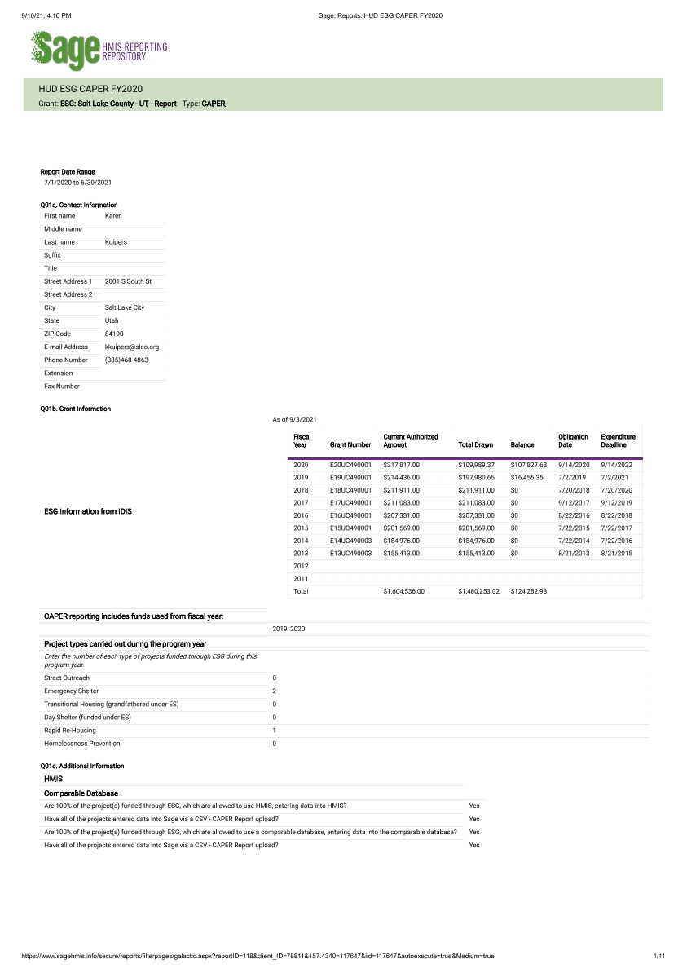
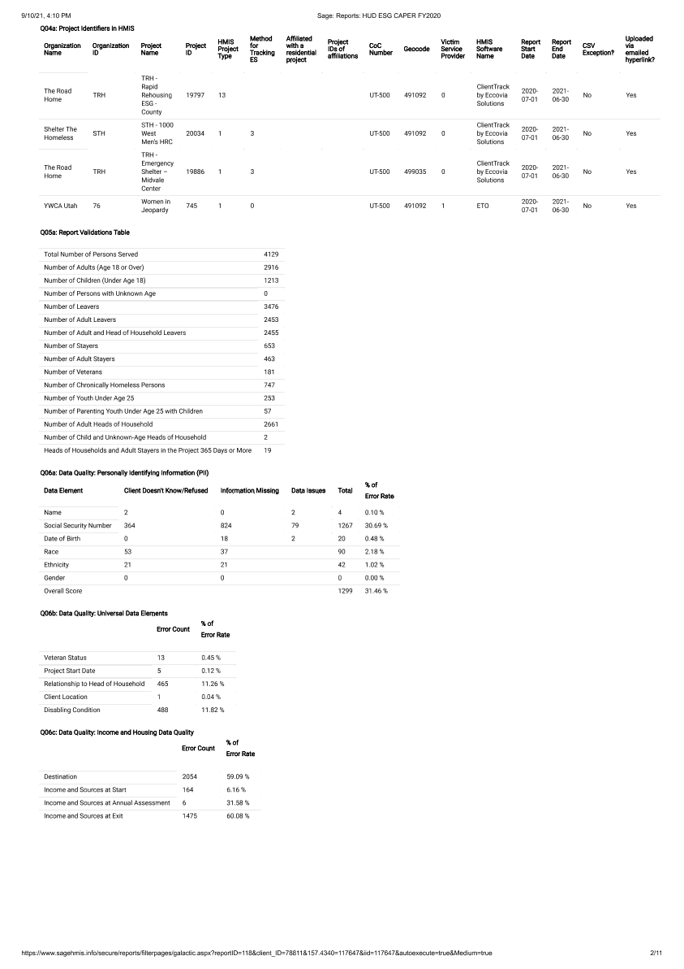
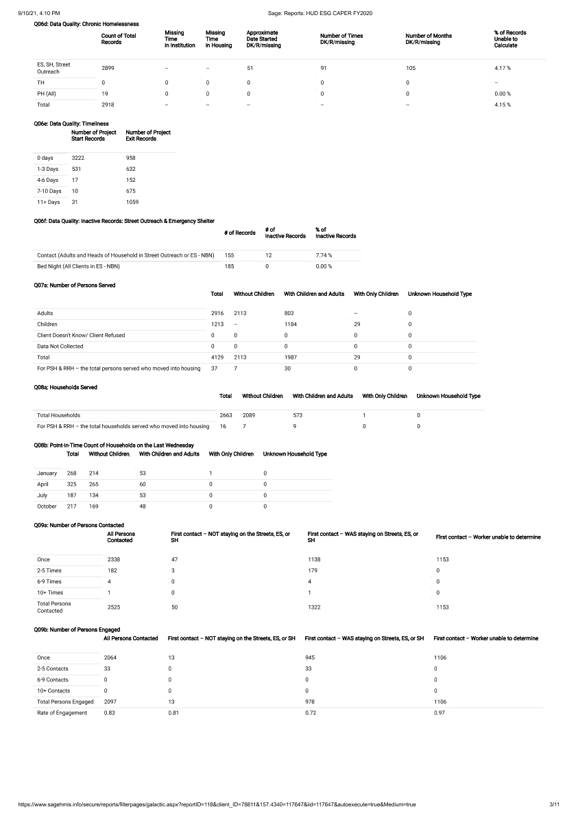
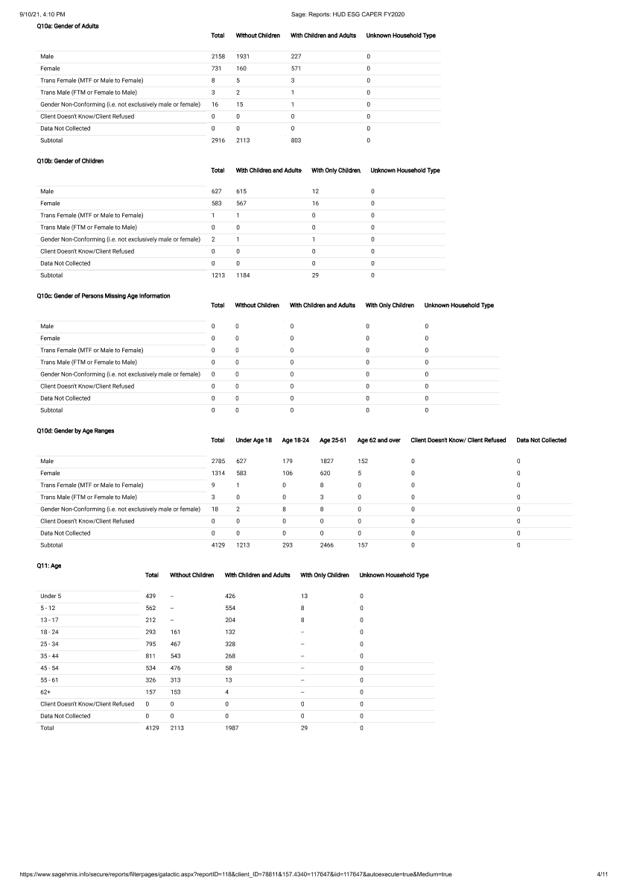
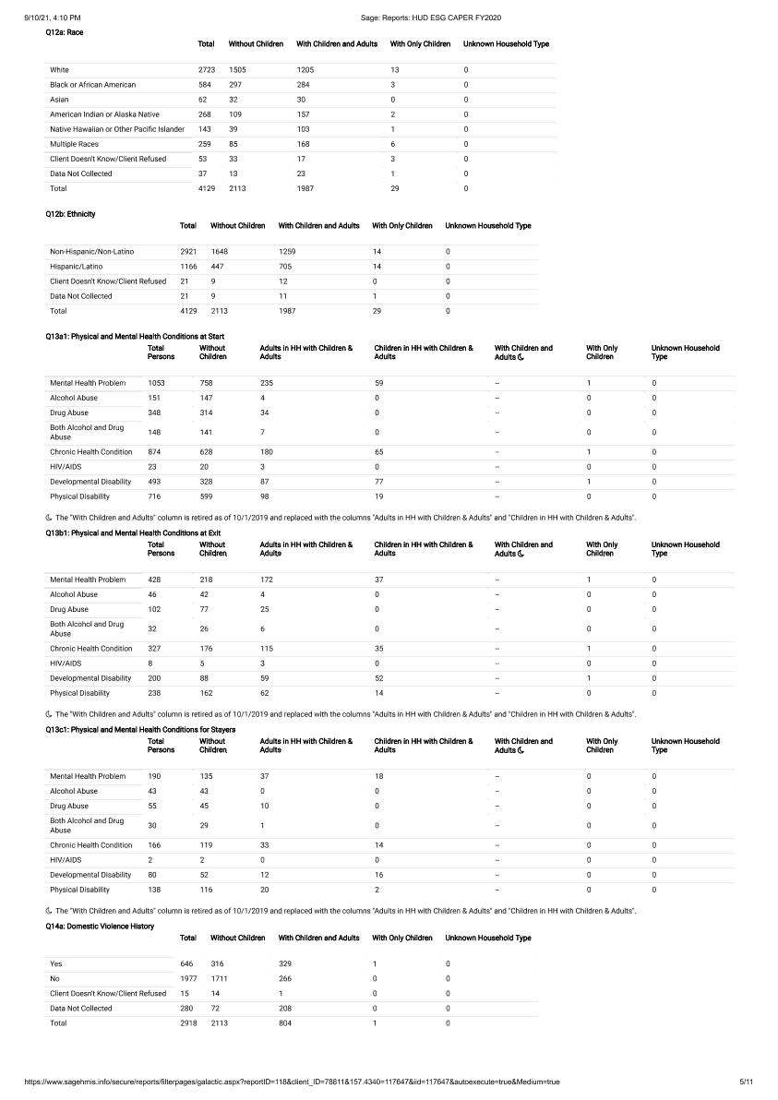
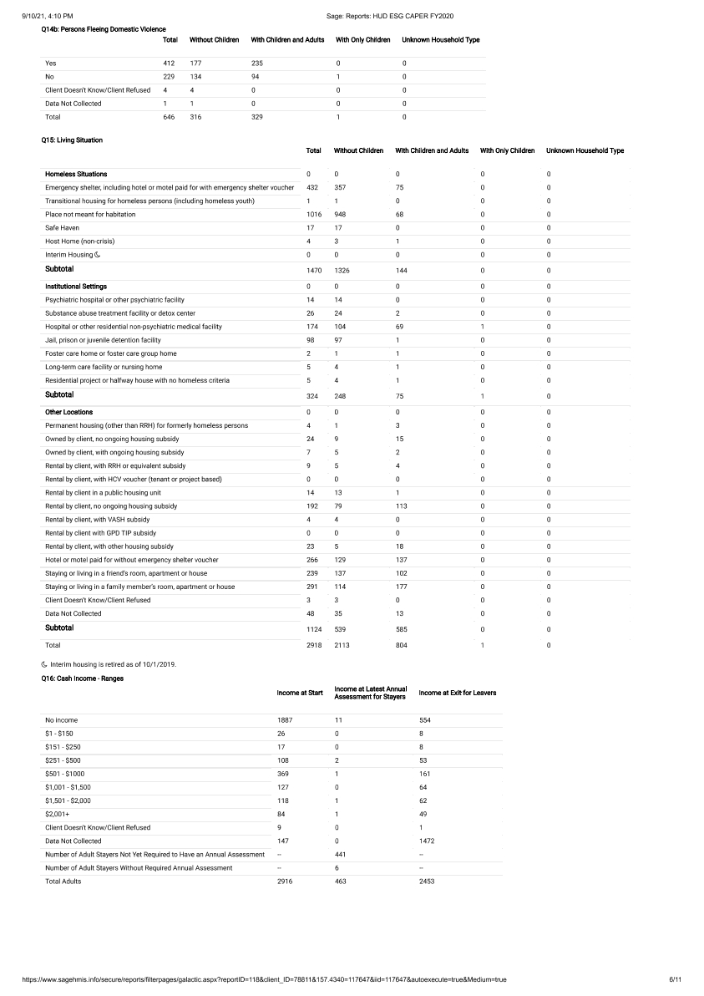
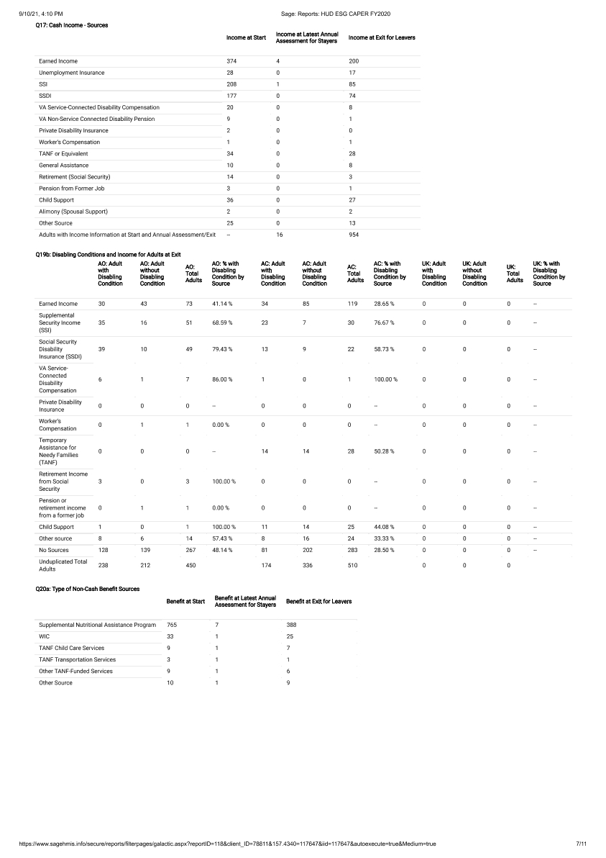
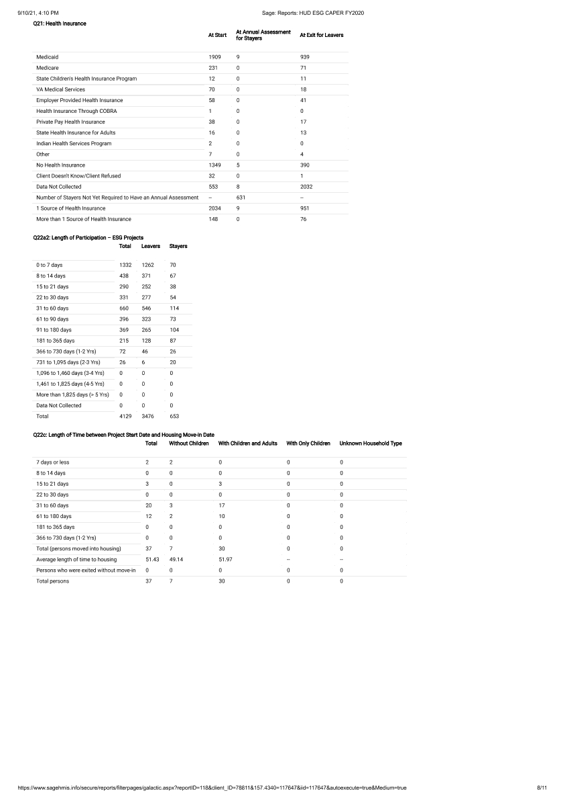
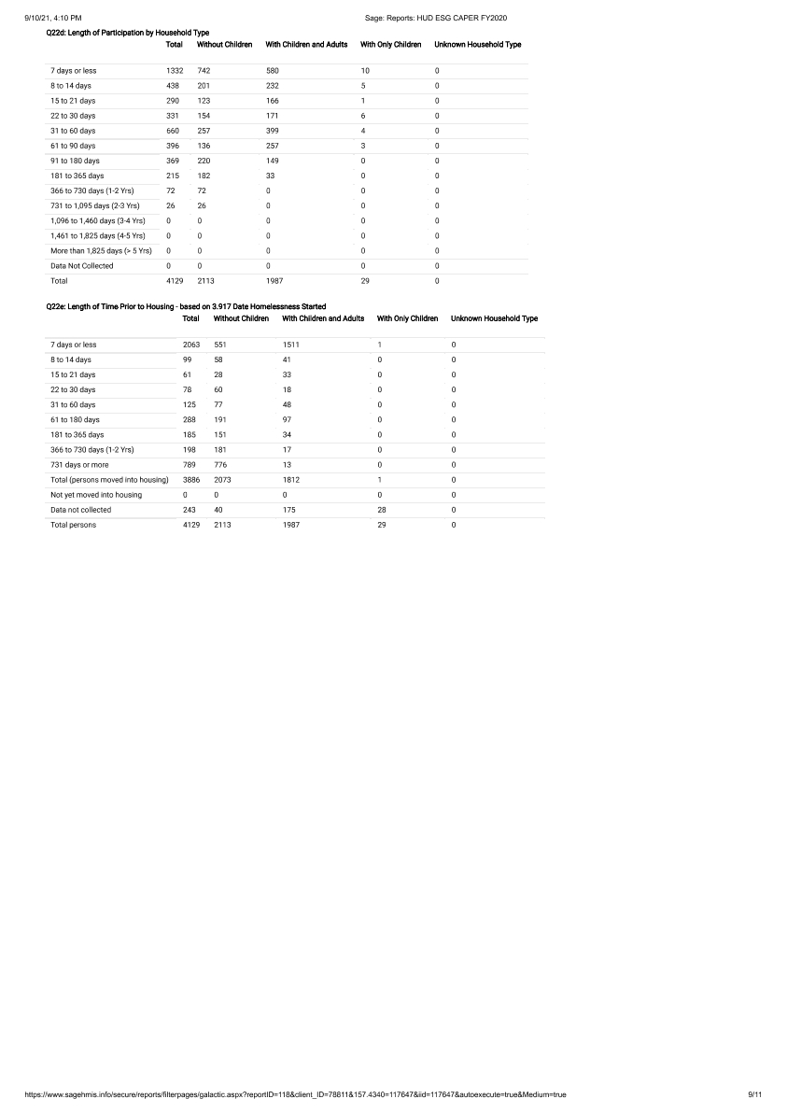
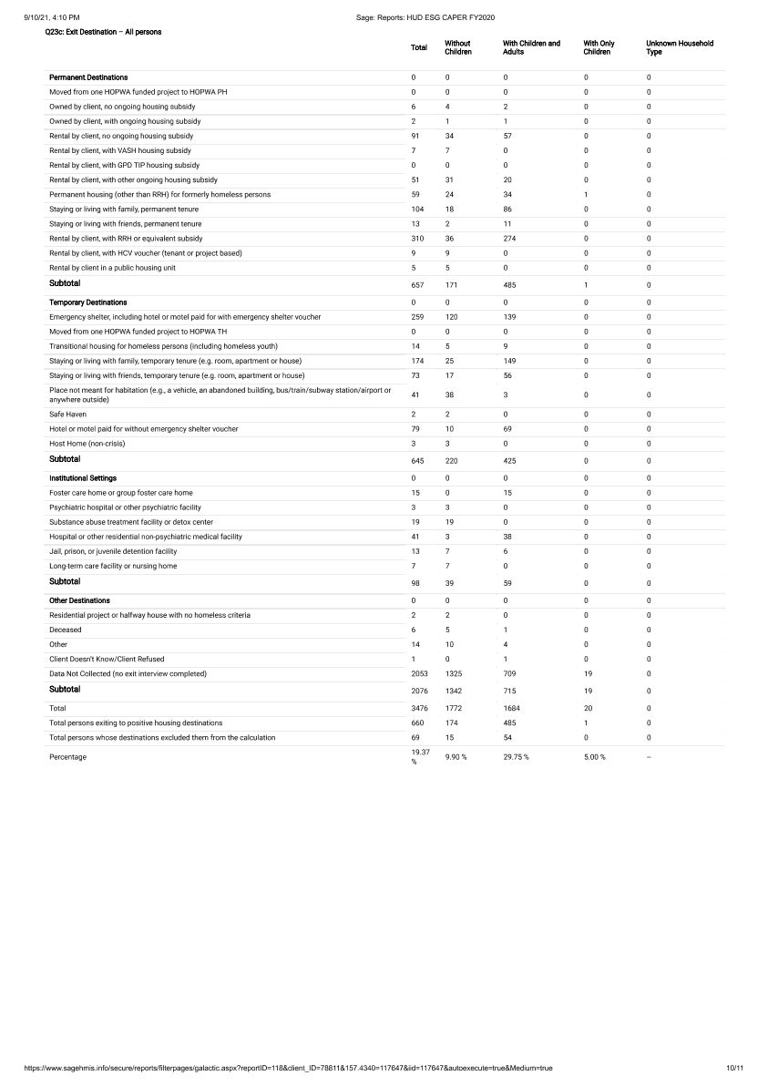
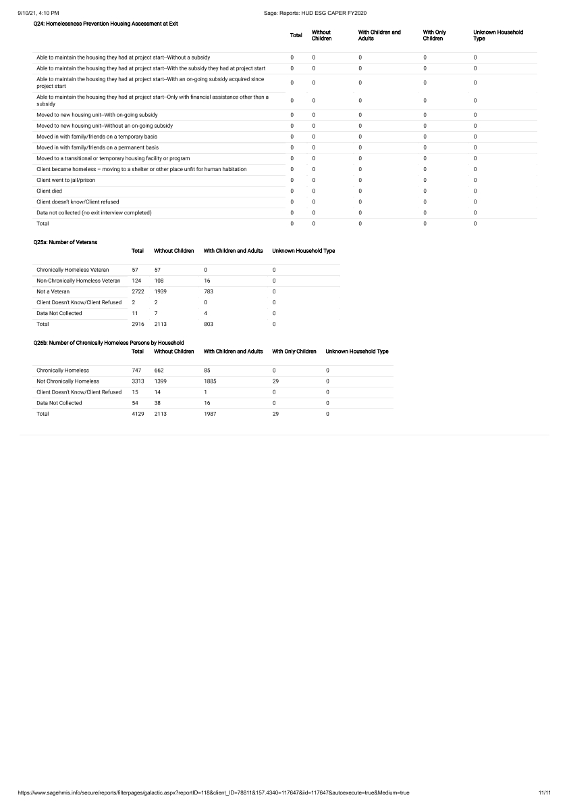

Draft CAPER with Attachments as provided for Public Comment
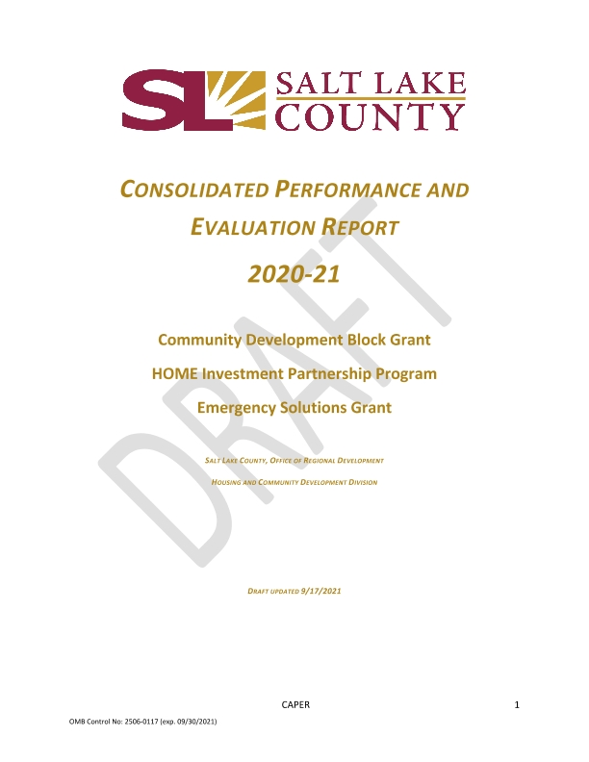
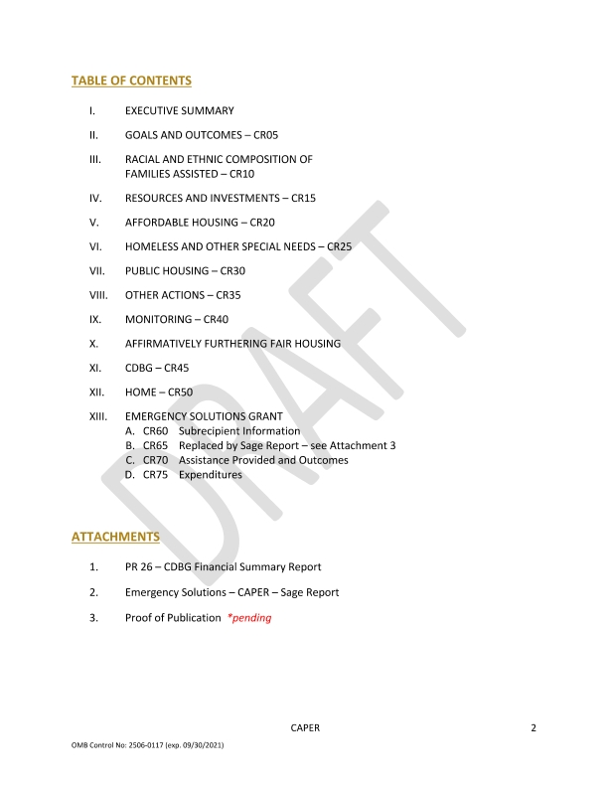
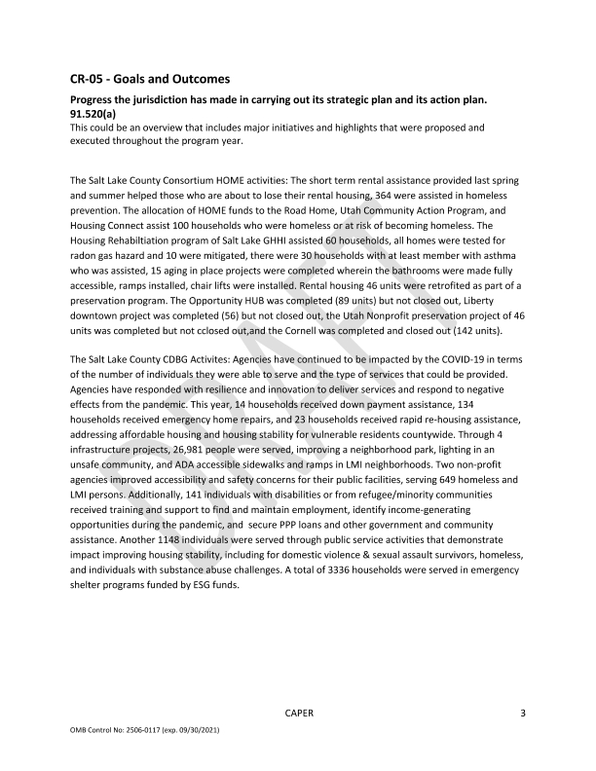
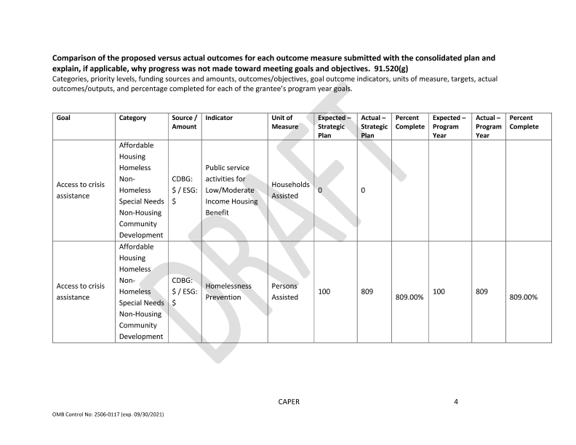
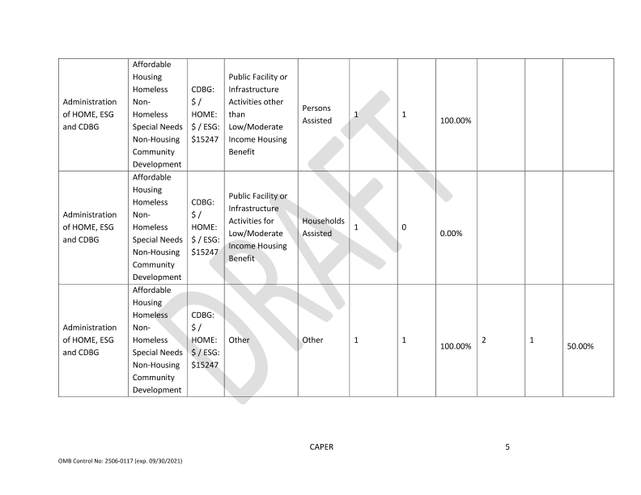
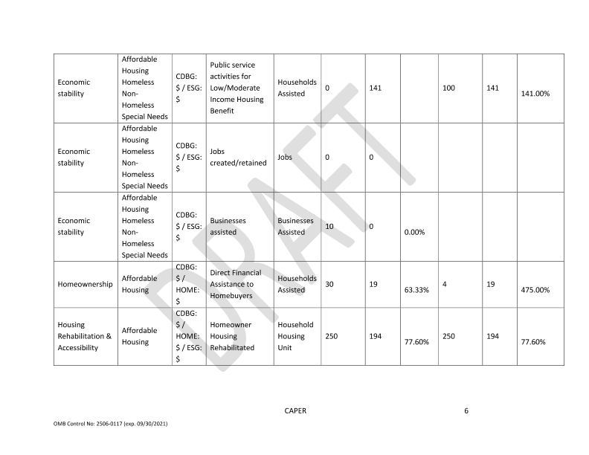
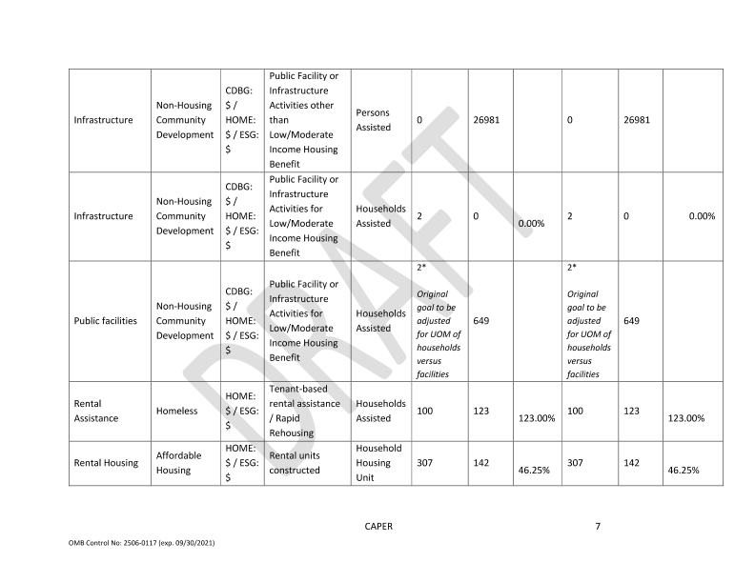
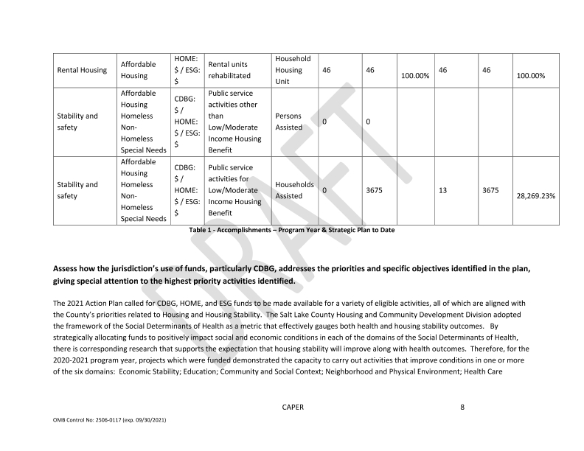
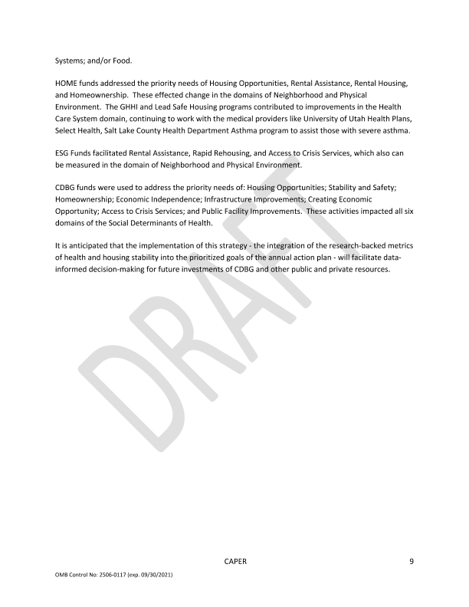
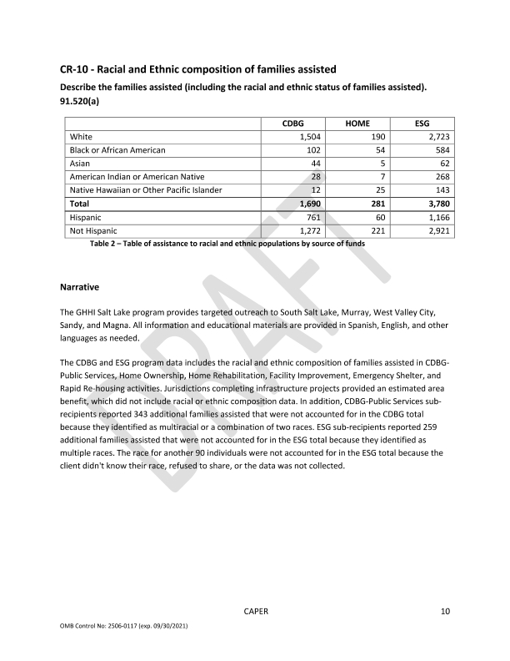
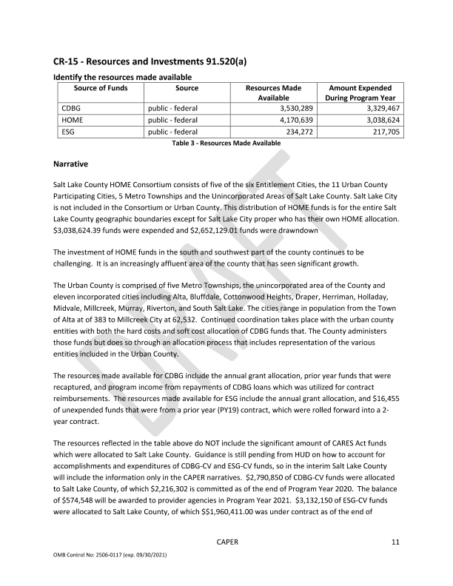
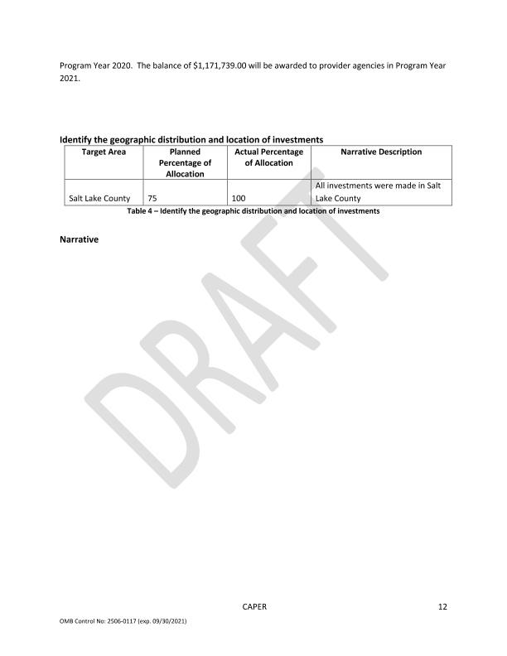
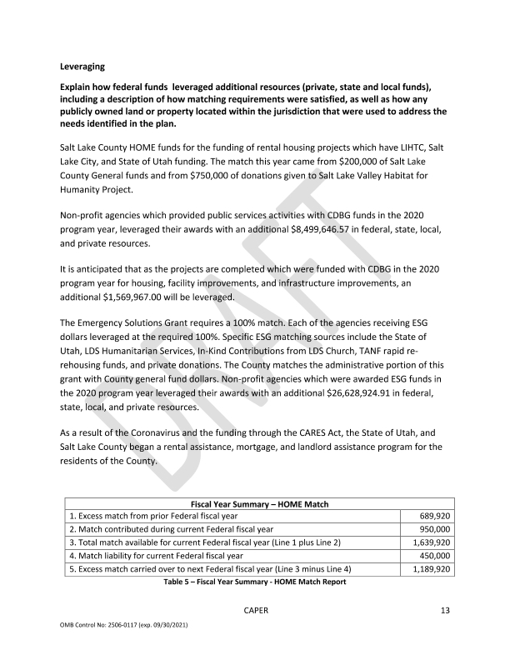
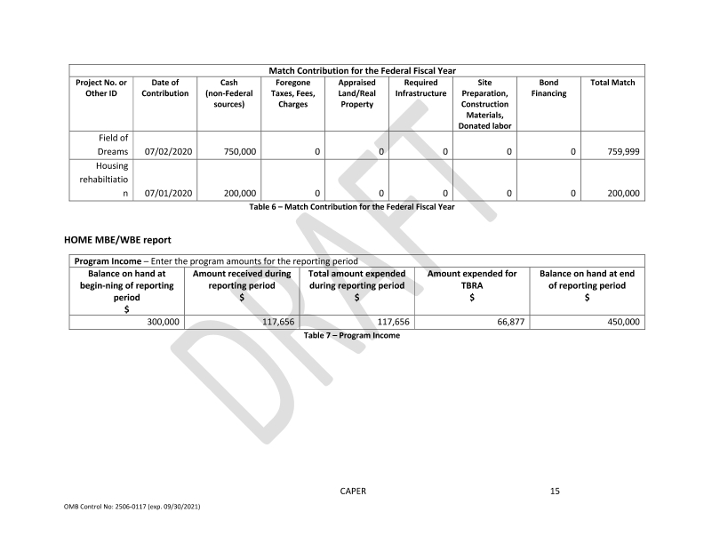
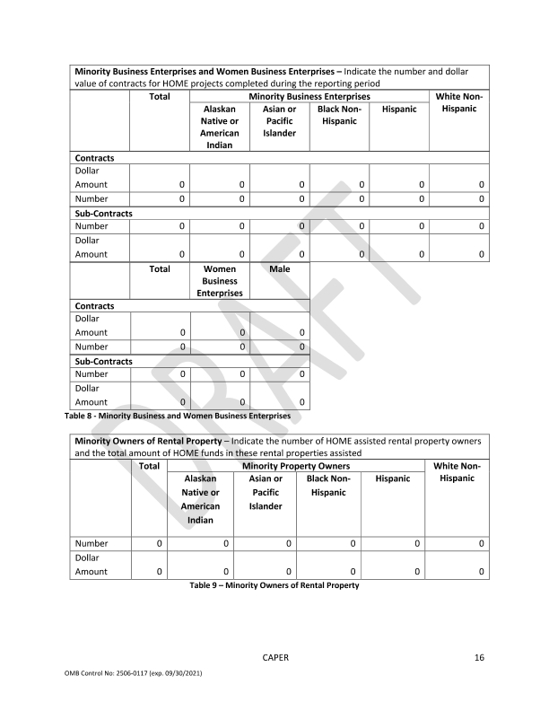
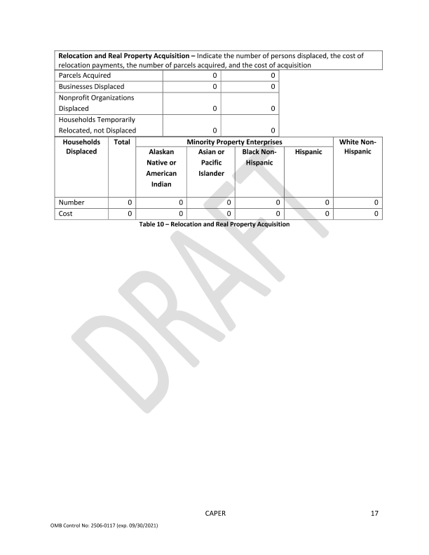
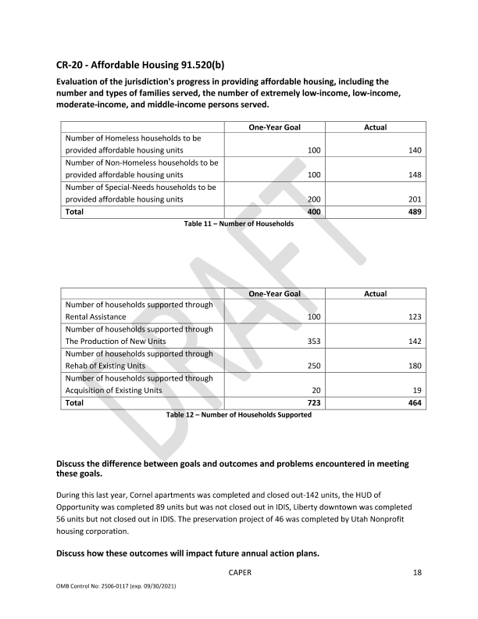
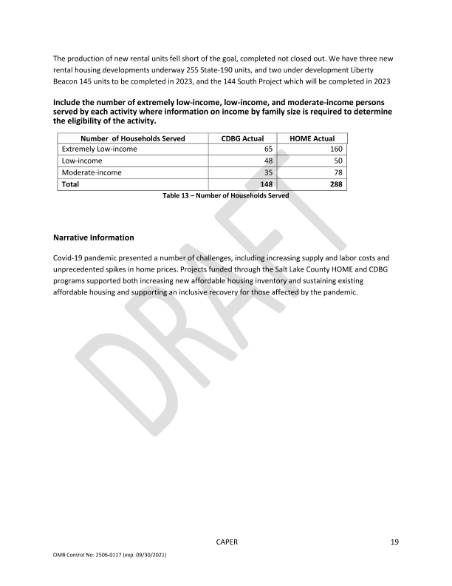
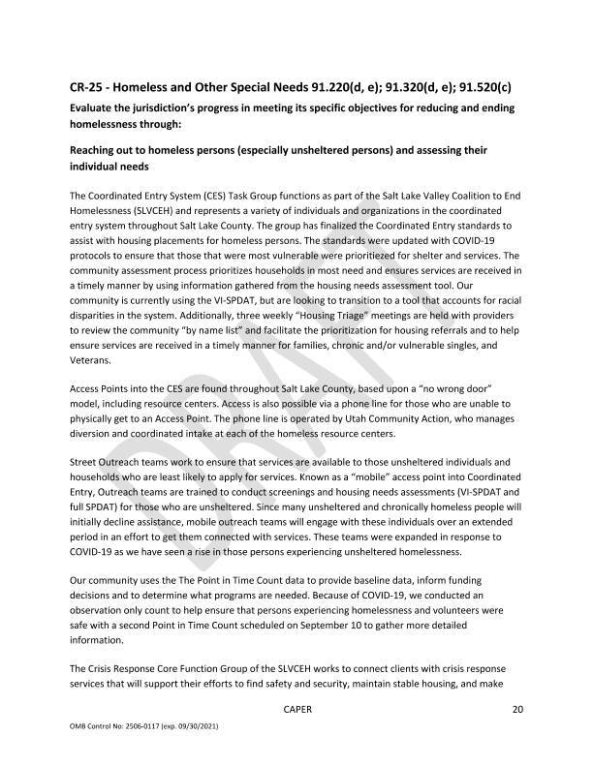
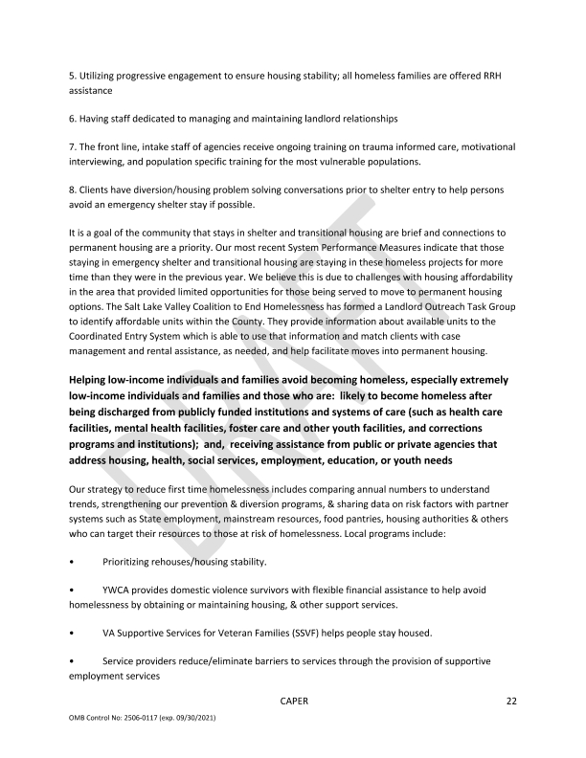
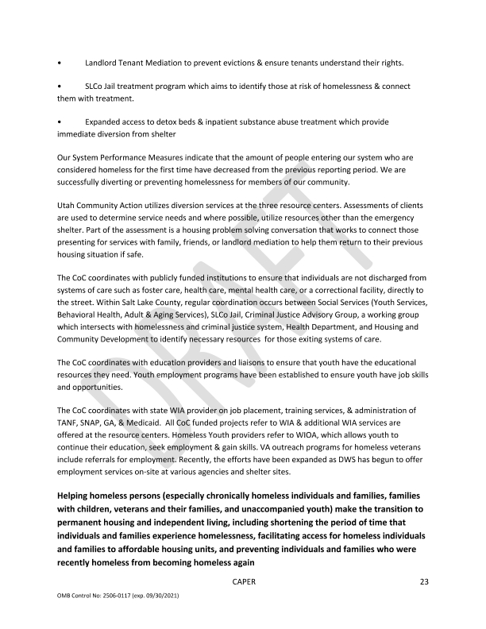
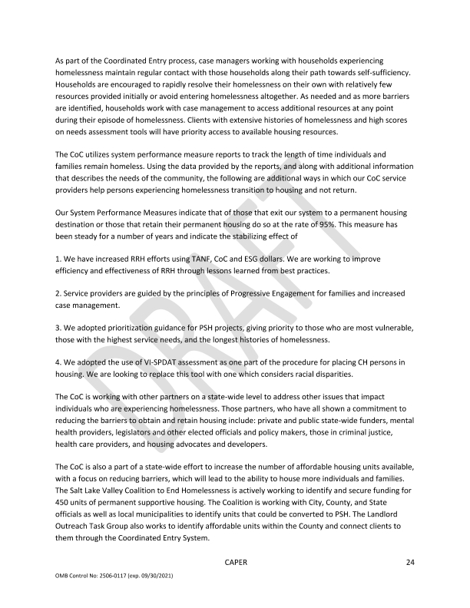
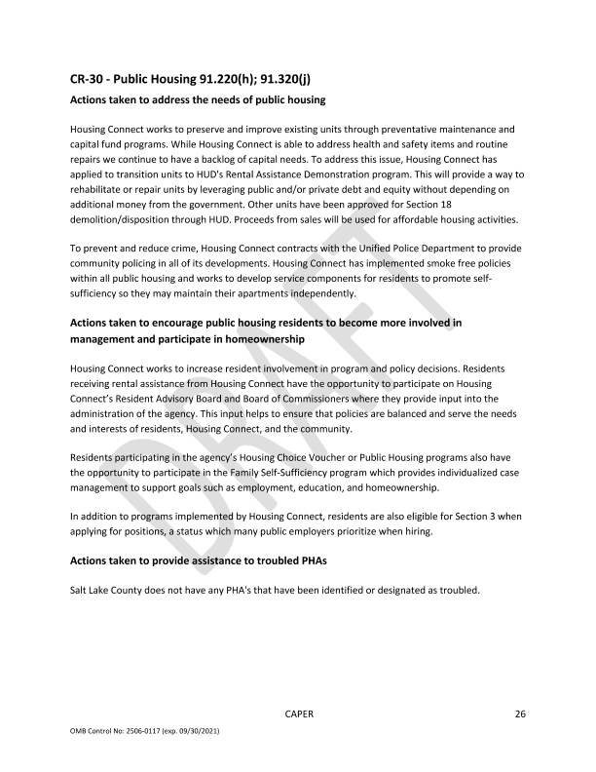
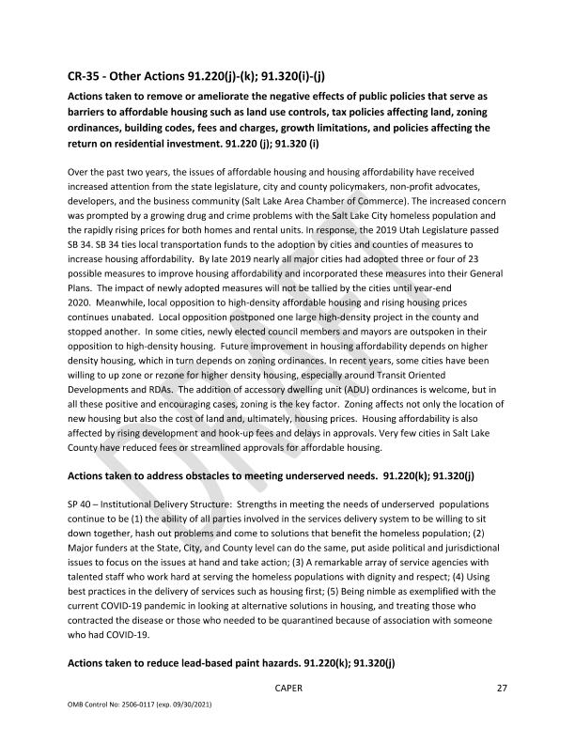
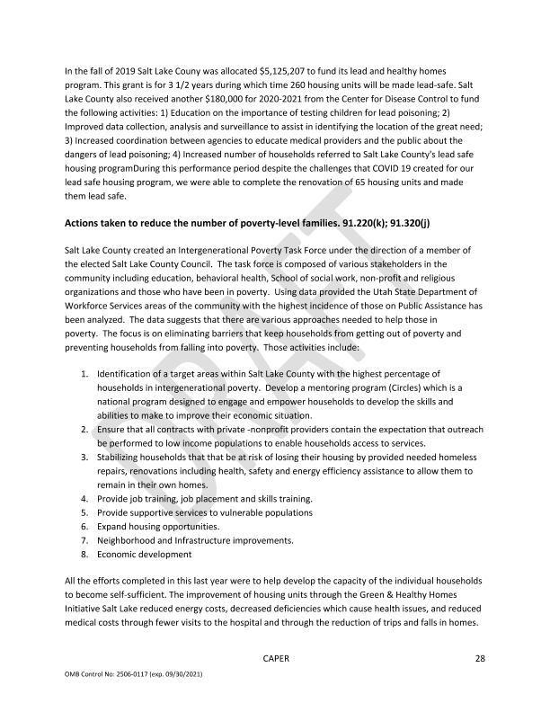
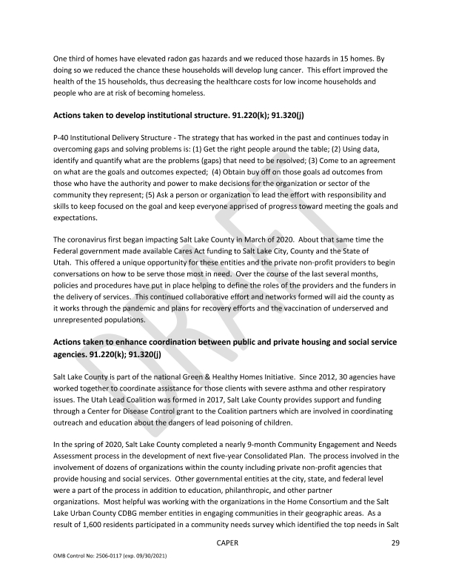
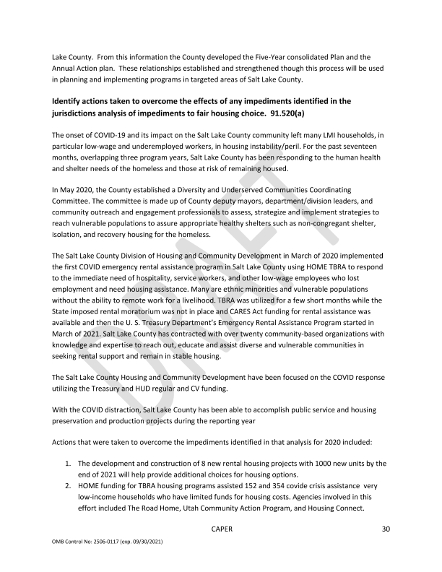
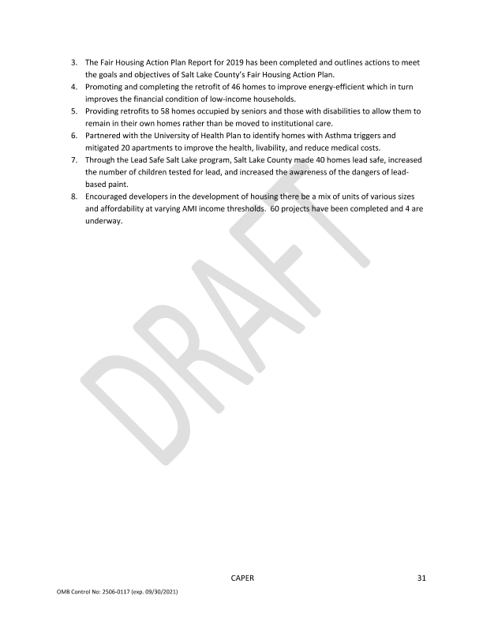
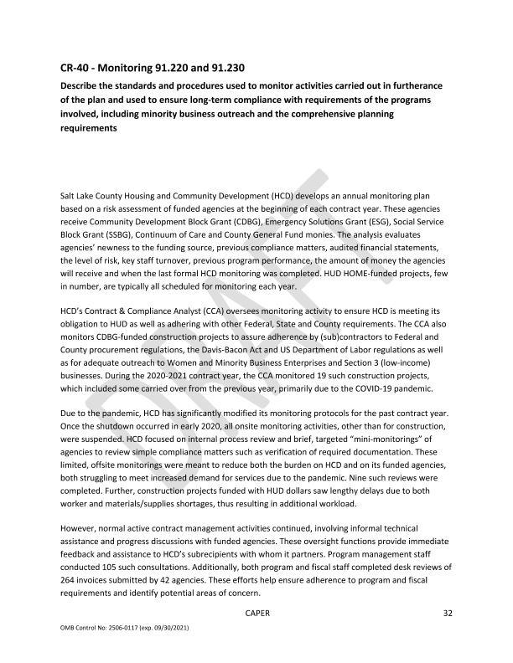
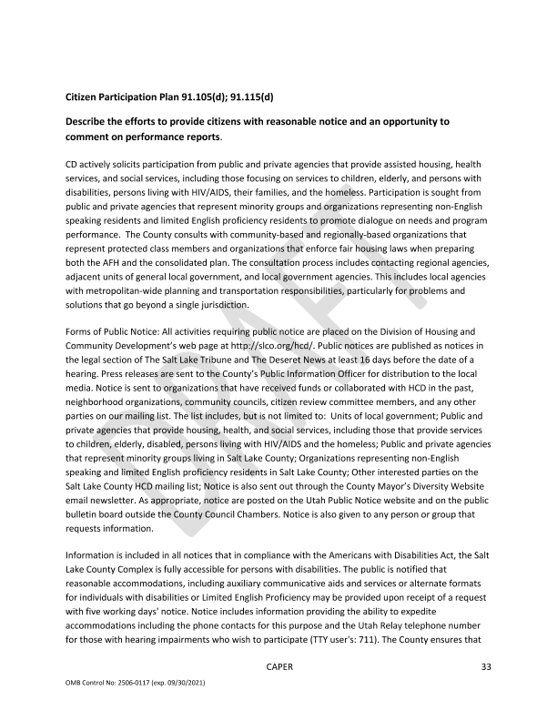
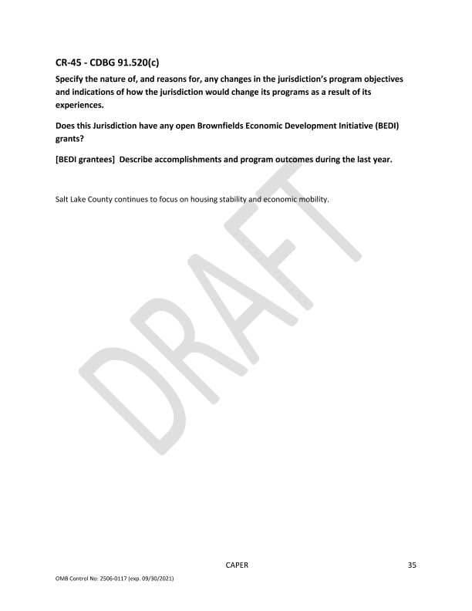
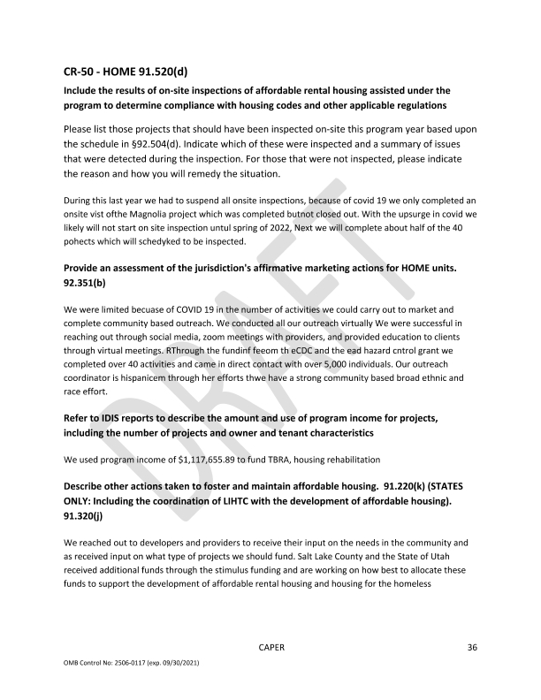
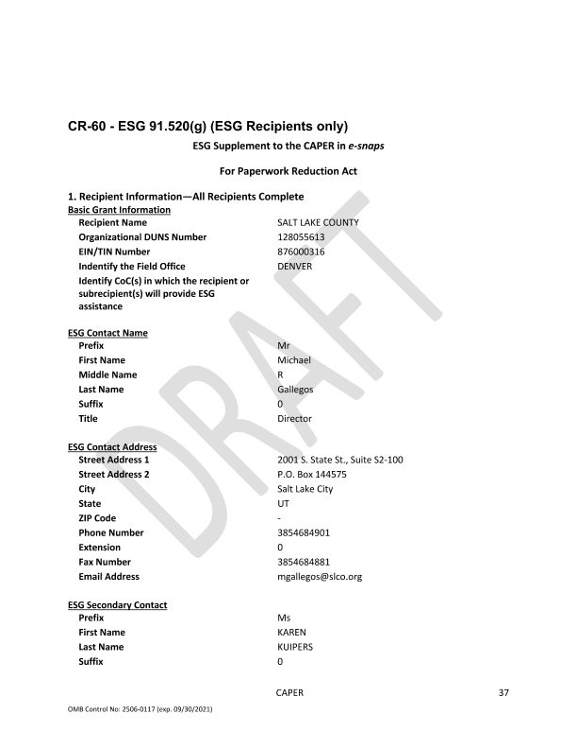
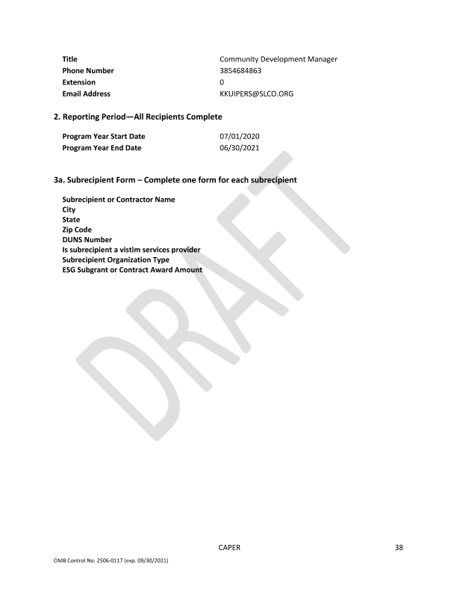
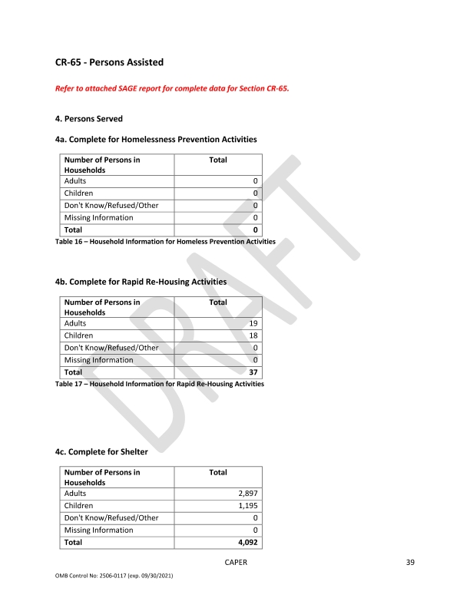
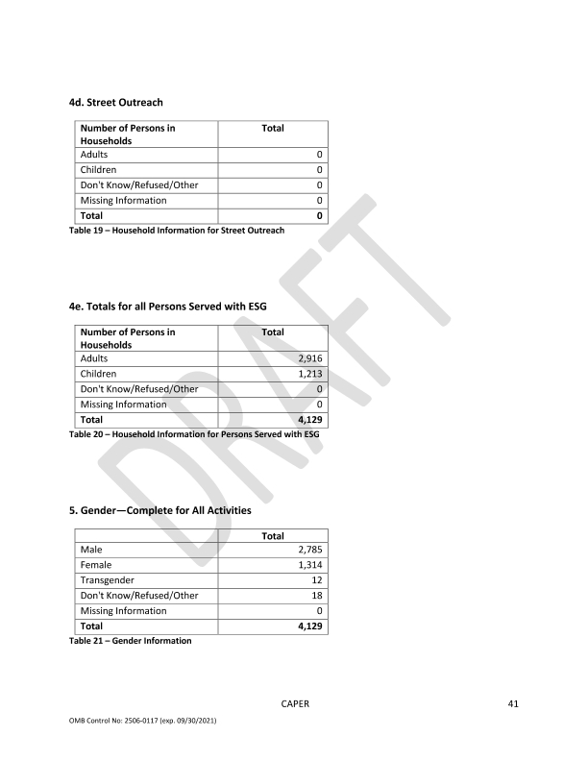
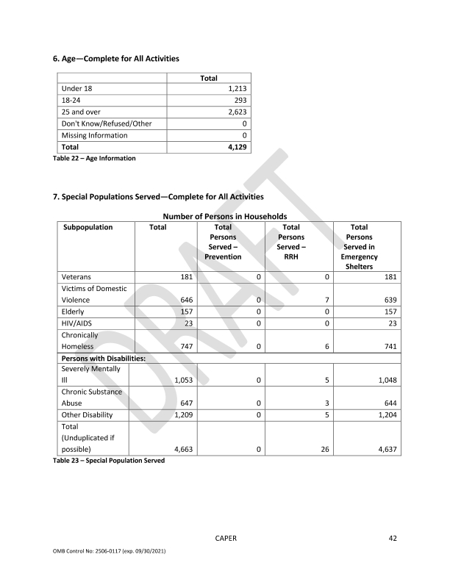
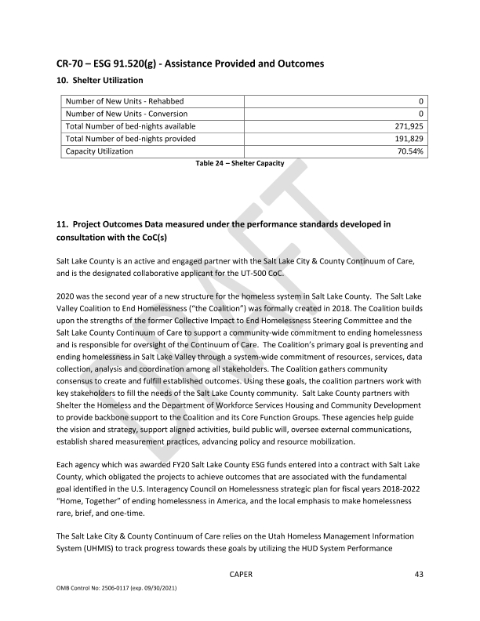
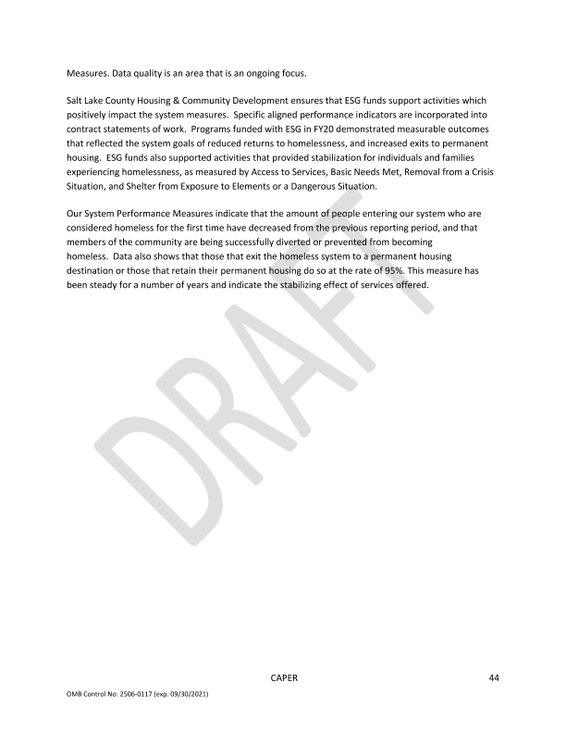
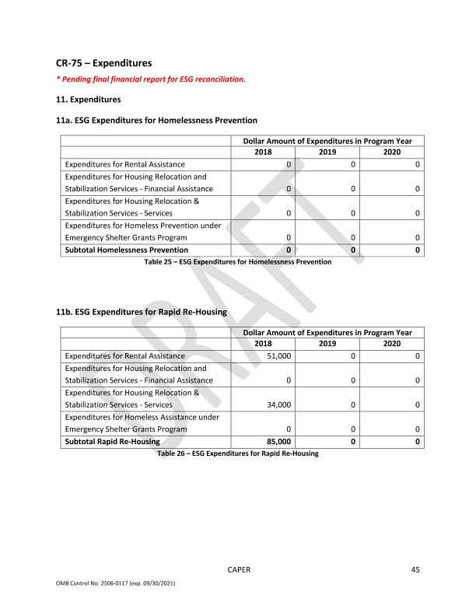
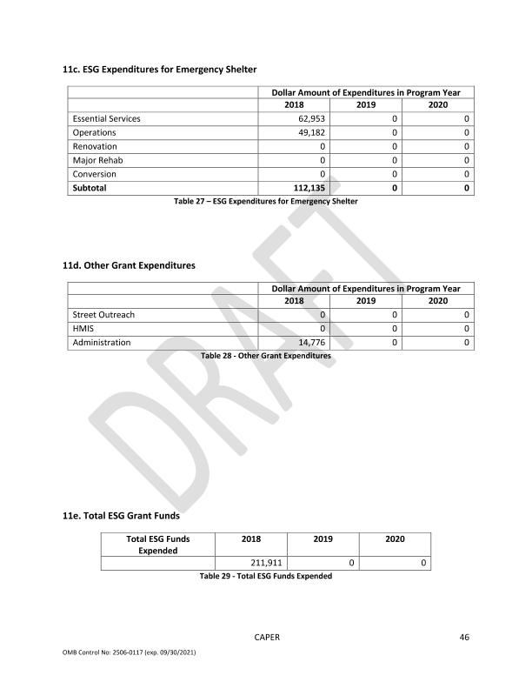
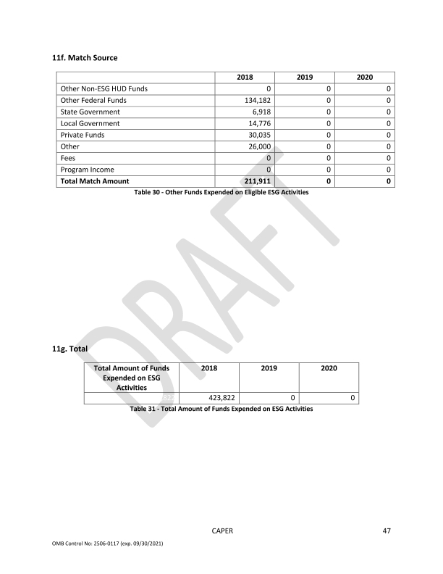
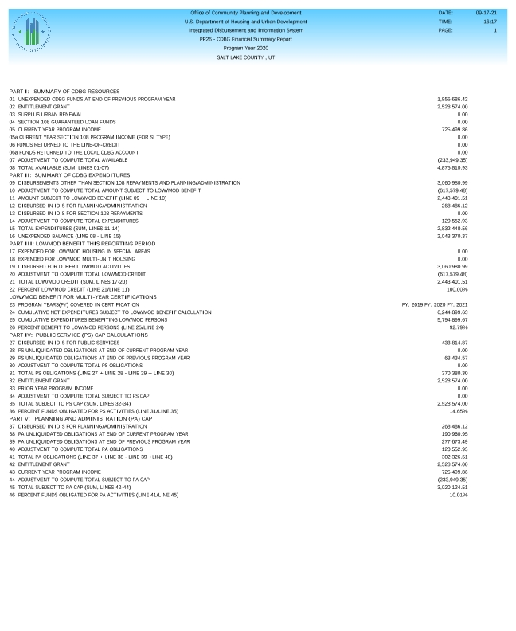
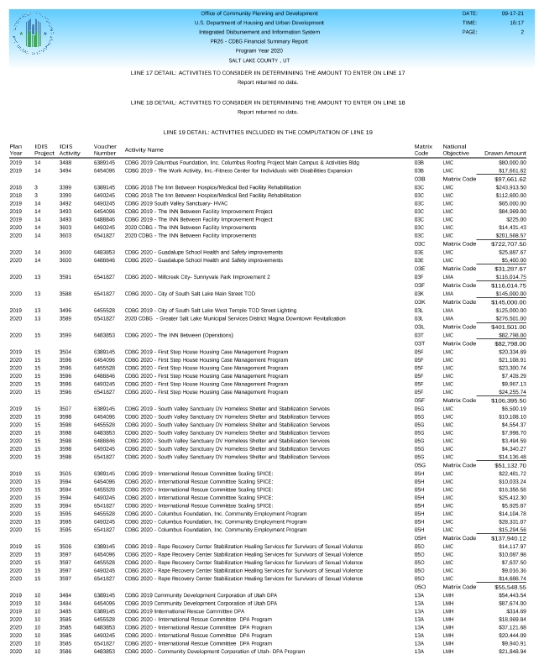
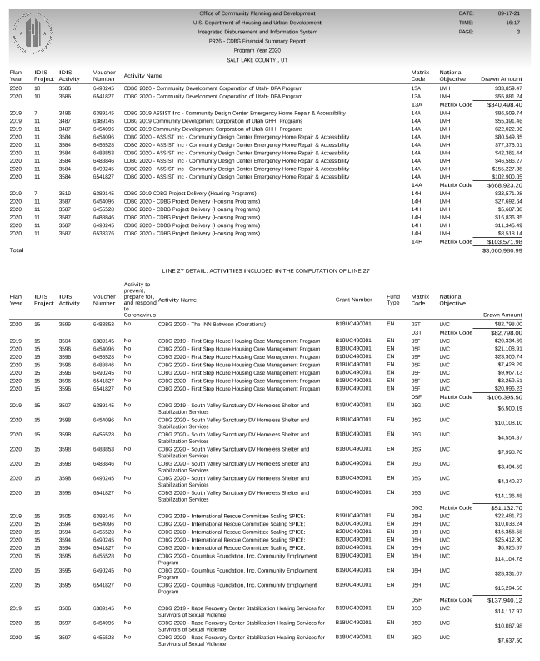
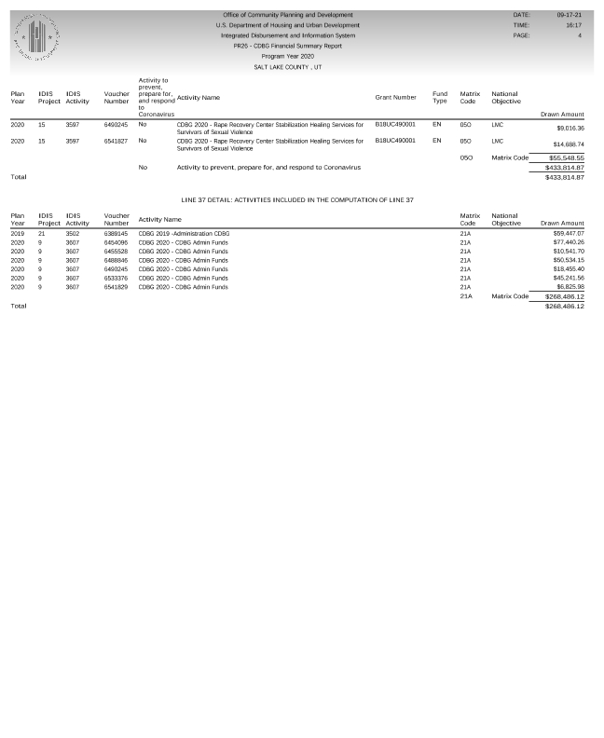
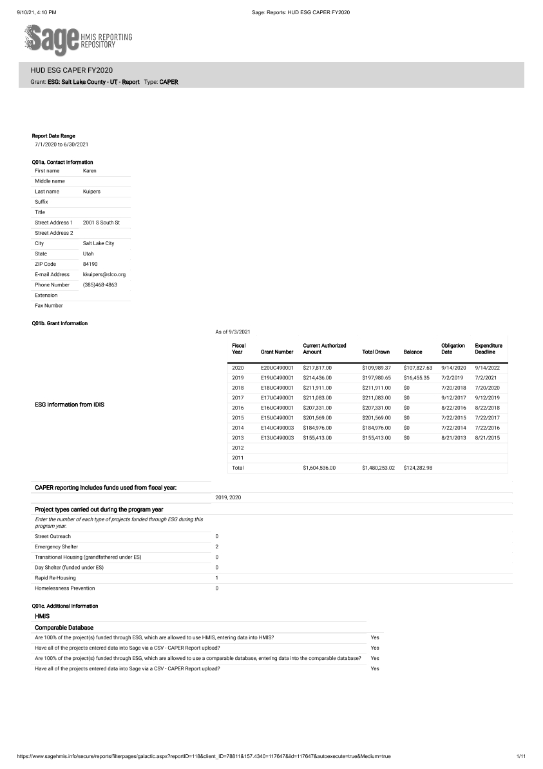
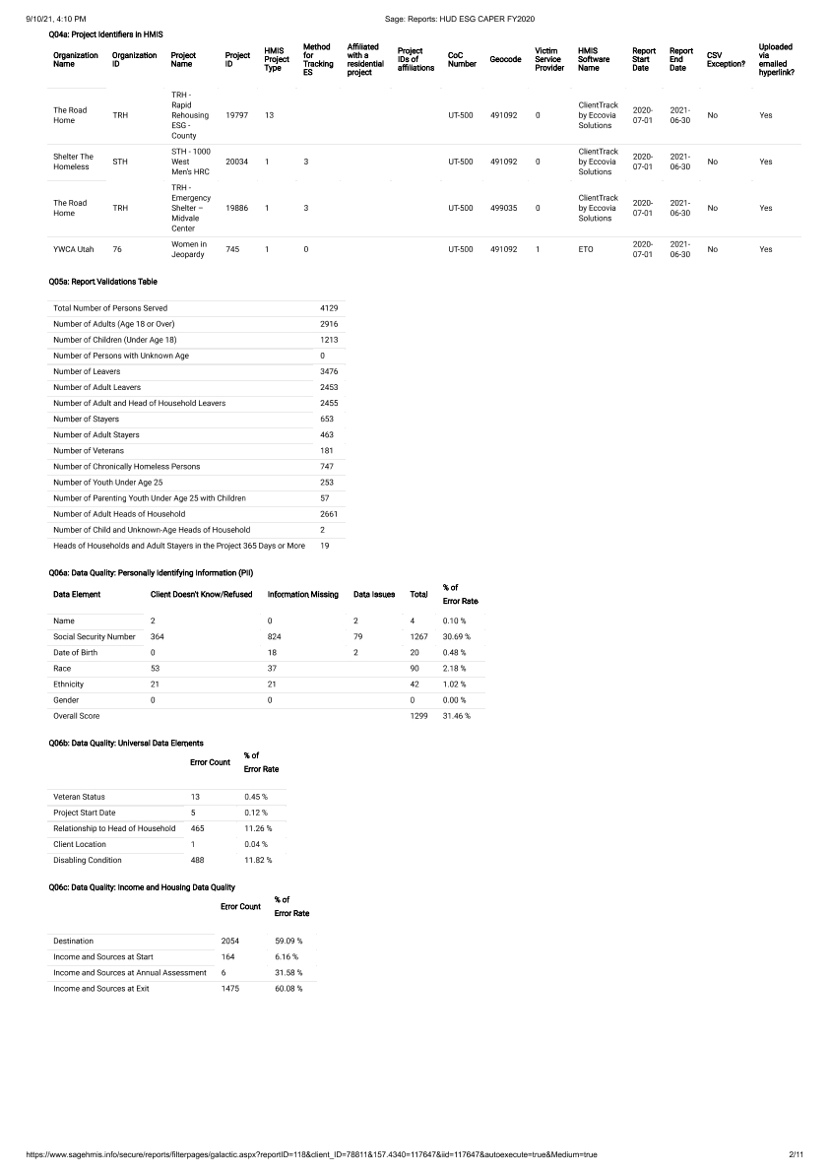
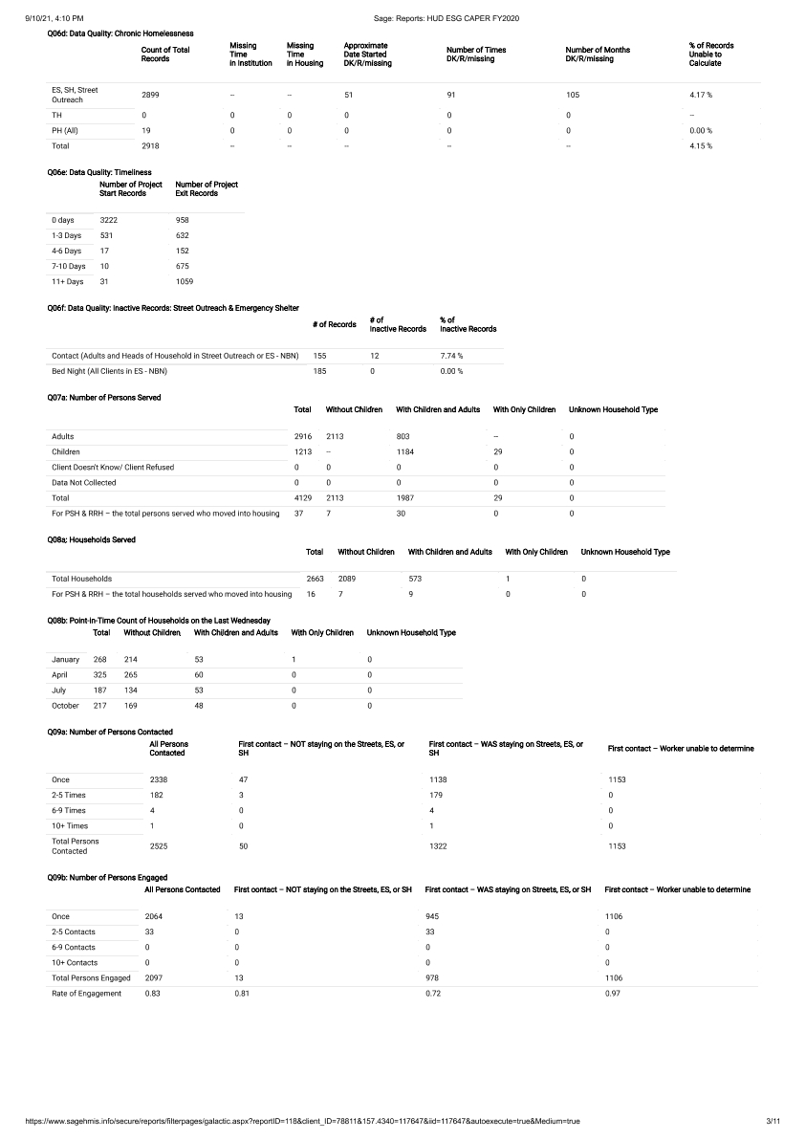
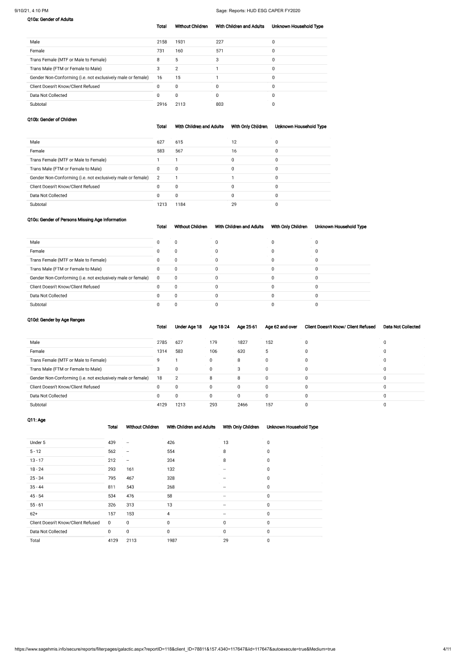
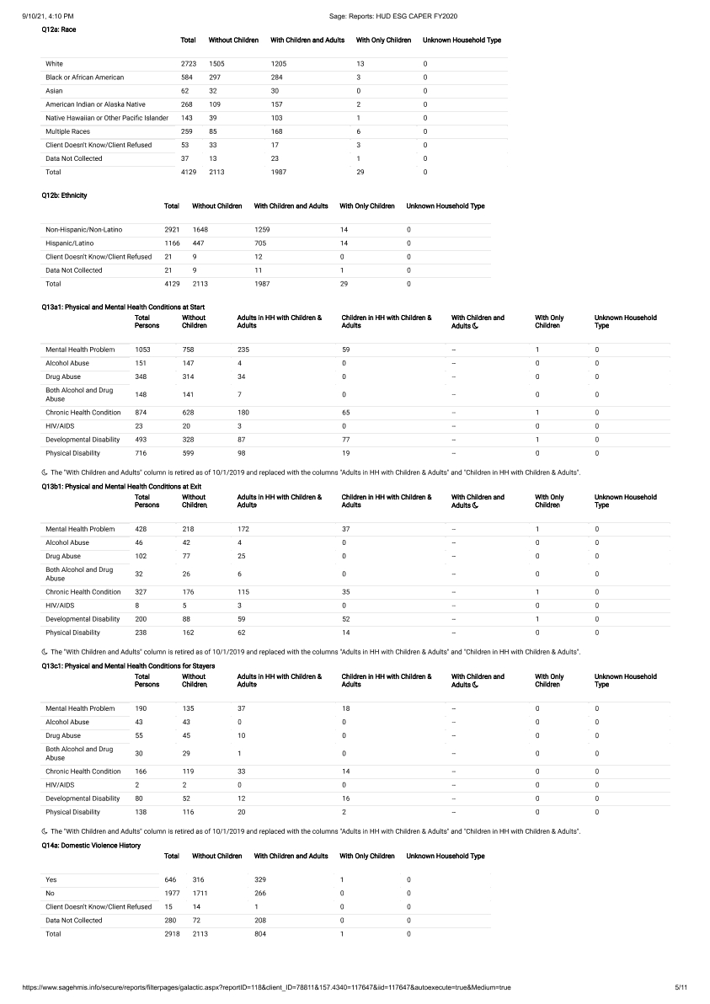
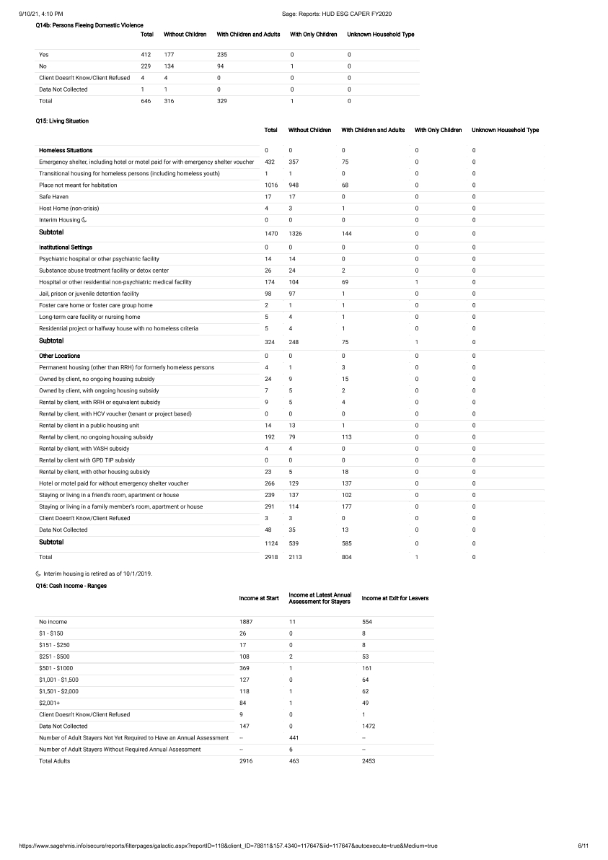
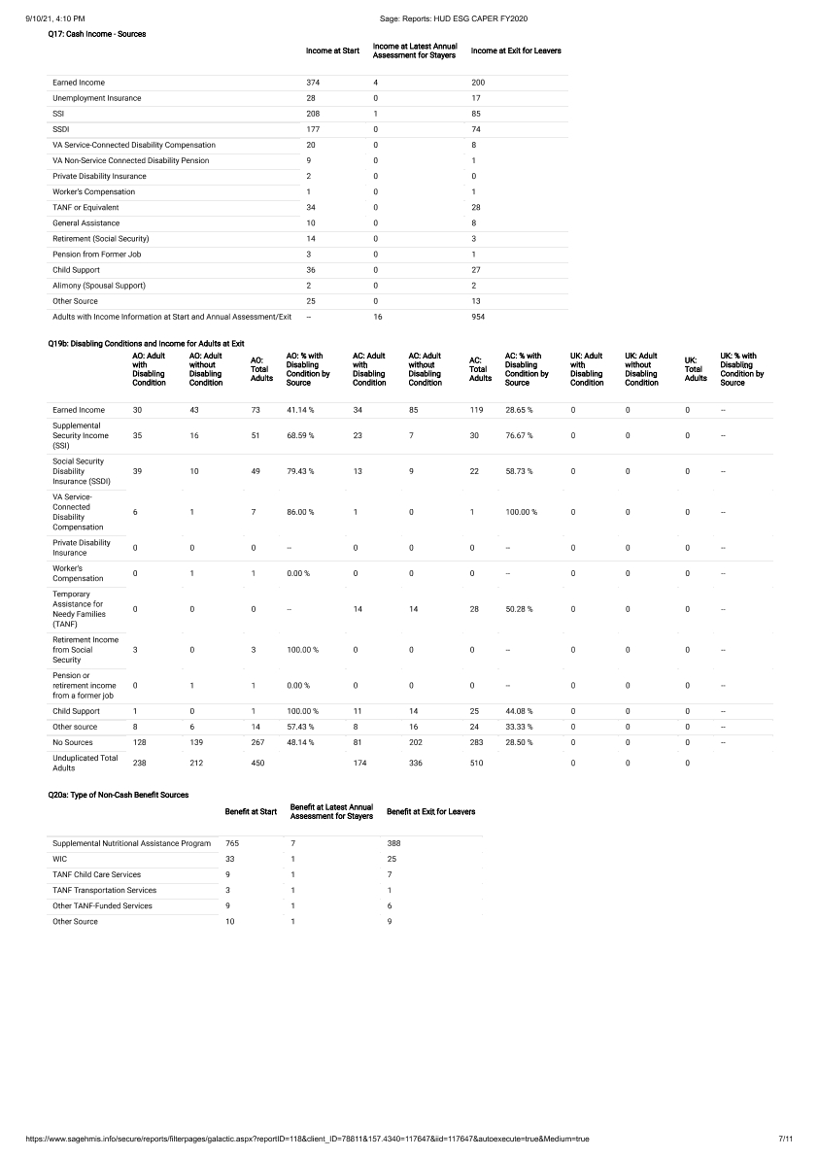
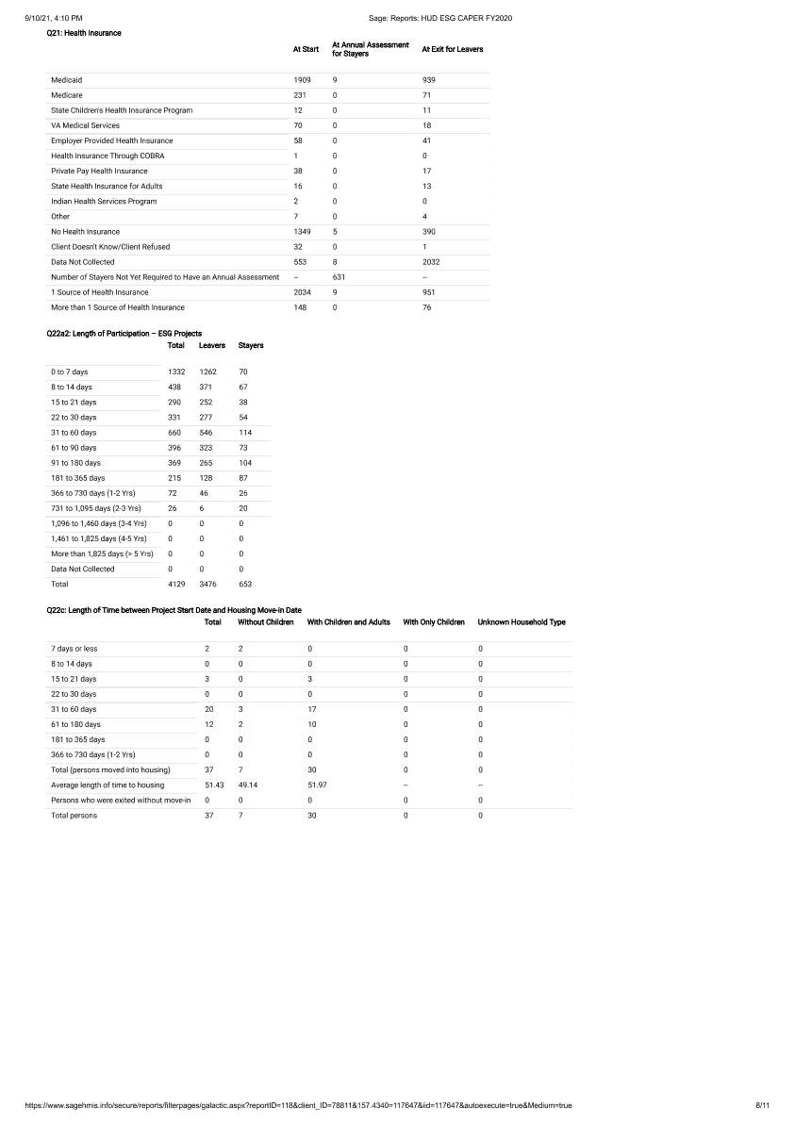
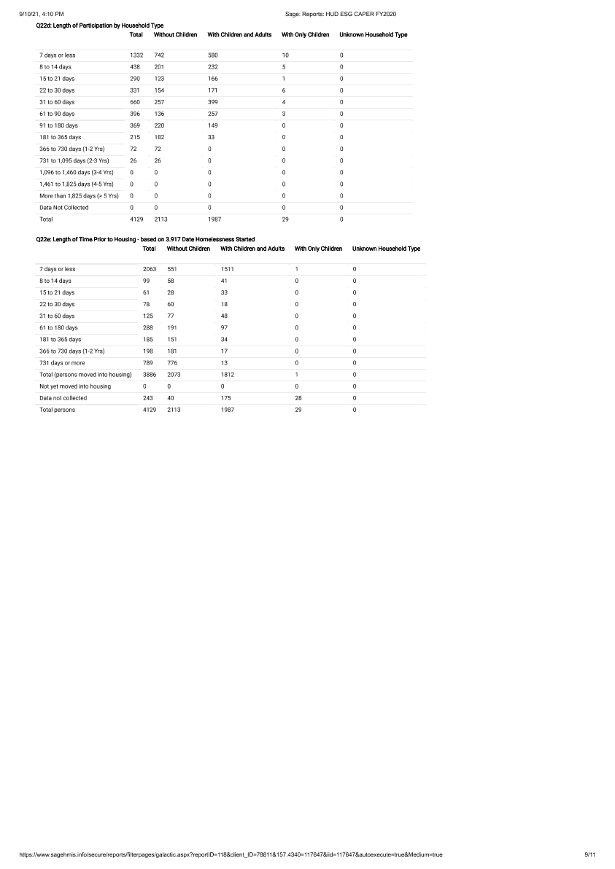
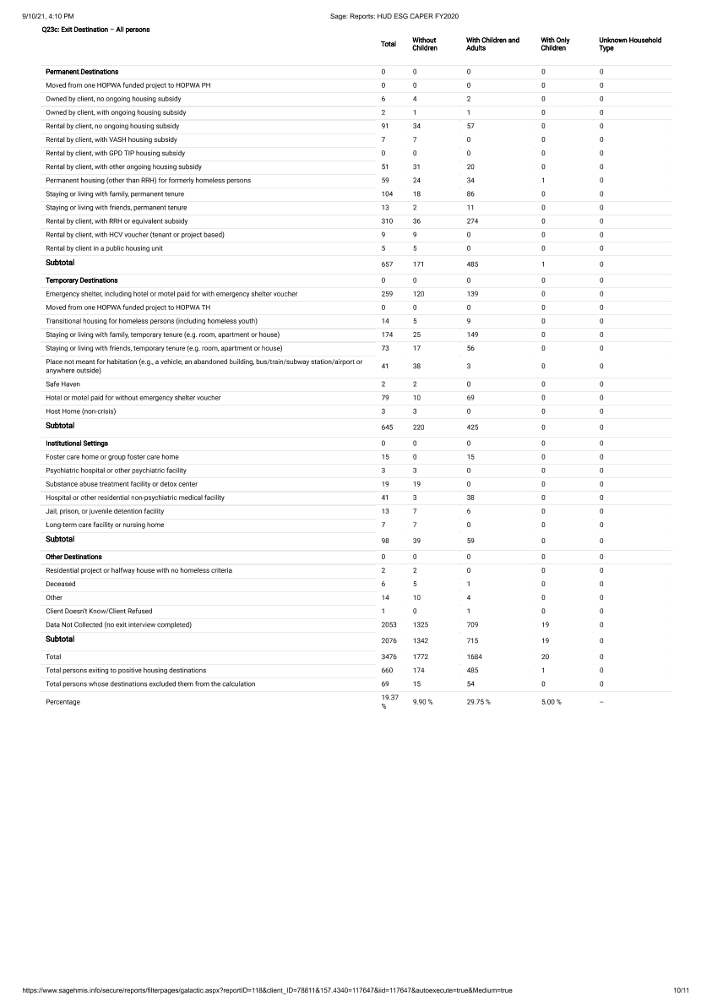
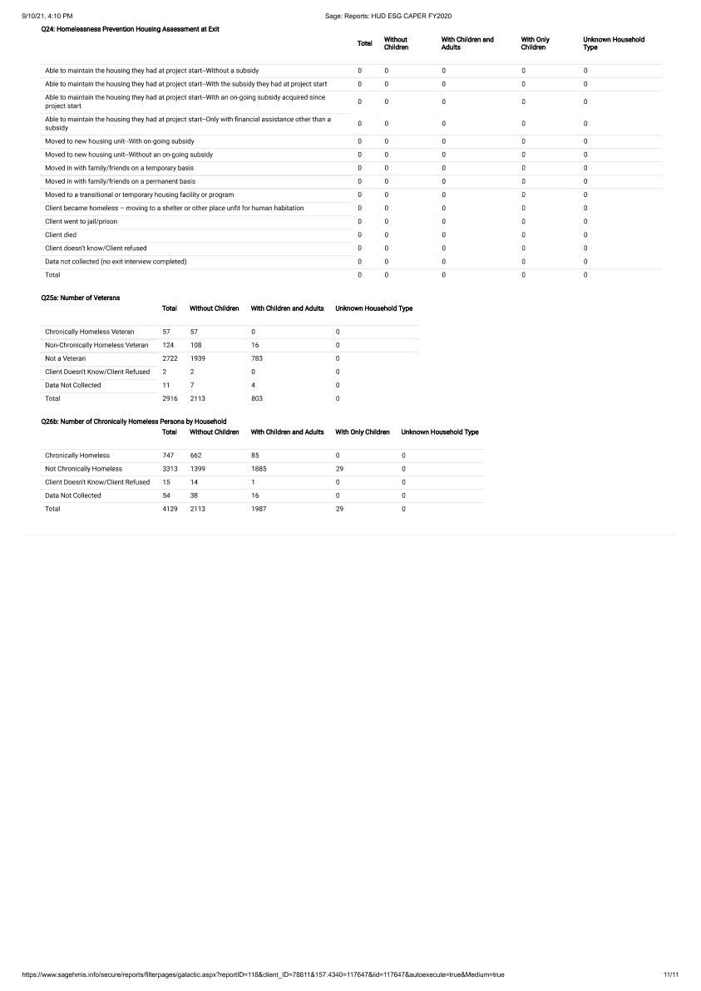

Proof of Publication Utah Public Notice Website
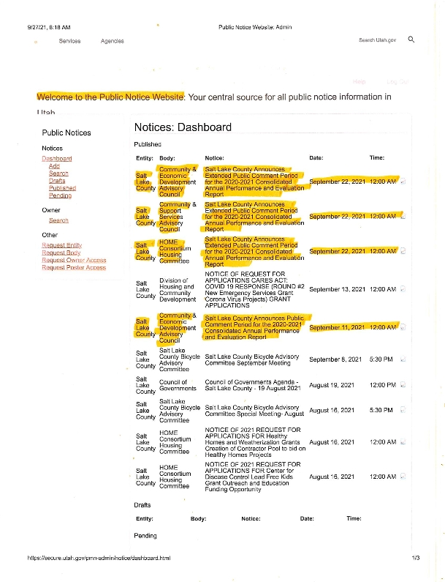

Proof of publication HCD Website
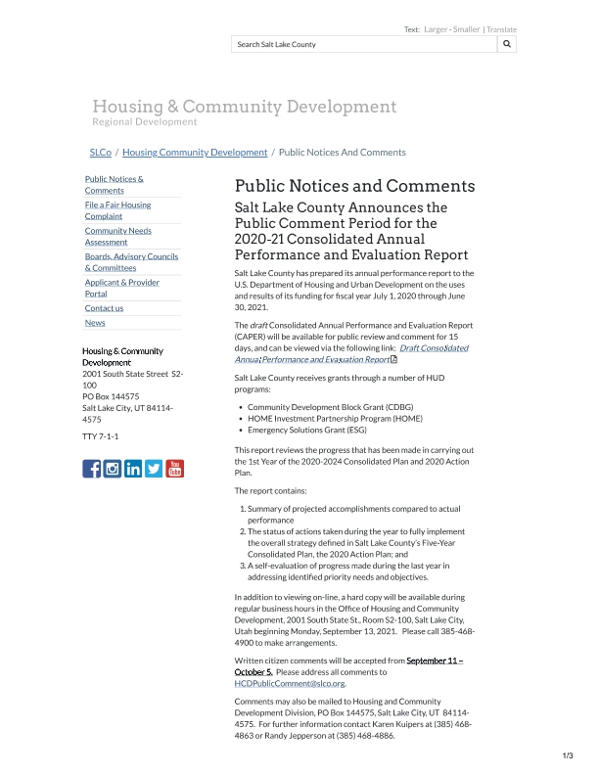
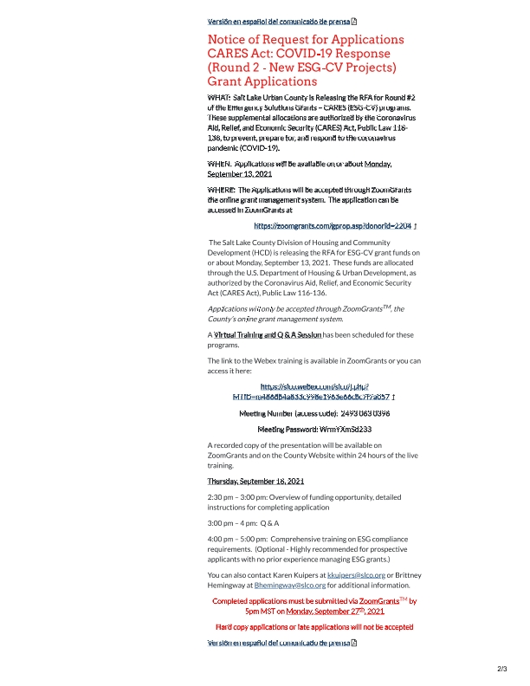
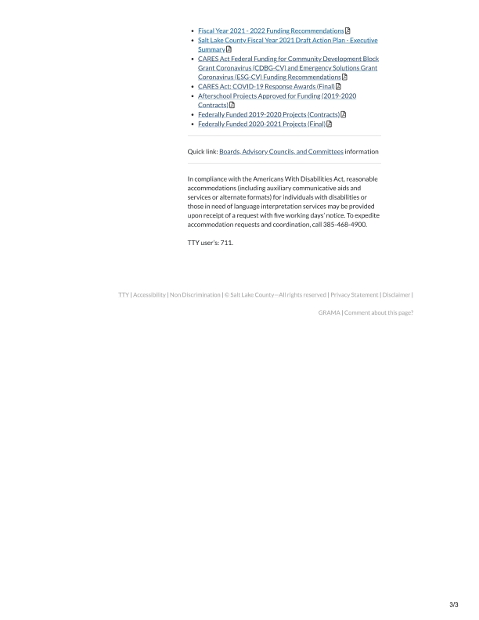

PR26 Financial Summary Report
